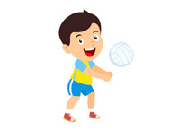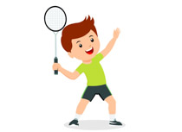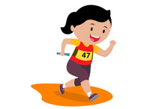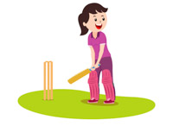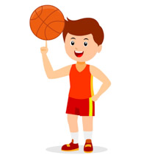

Year 7 My Best Work Project

**Core PE**

Opportunity to Pick Sports Studies for GCSE

All students in Years 7-10 participate in our annual sports day.

Sports Ties Awarded

Vale Rugby, Football & Netball Fixtures

County tennis Fixtures

Inter Tutor Netball & Football

Vale Rounders Fixtures

Vale Badminton Competition

Vale Rugby, Football & Netball Fixtures

Vale Rounders & Softball Fixtures

Vale Rugby, Football & Netball Fixtures

Vale Rounders & Softball Fixtures

County Cross Country Competitions

Super6 Athletics Competition

Vale Badminton Competition

Vale Rounders Fixtures

Super6 Athletics Competition

Inter Tutor Netball, Football & Badminton

Vale Rugby, Football & Netball Fixtures

Super6 and Indoor Athletics Competitions

Vale Rounders & Softball Fixtures

Vale Rugby, Football & Netball Fixtures

Vale & County Cross Country Competitions

Inter Tutor Netball & Football

Quadkids and Indoor Athletics Competition

Vale Cross Country Competition

In year 7 students will increase their competence and confidence in using range of fundamental sports skills and strategies. They will begin to understand some of the short term effects of exercise on the body as well as building their resilience and co-operation through a range of challenging activities. Students will also begin to reflect on their own performance through self-assessment.

In year 11 students look to take responsibility for their own physically activity choices, selecting activities that suite their fitness levels and confidence. The majority of students will now be applying skills and strategies in full context and will have increased autonomy over the design of the lessons. More confident students will be given responsibility for organising elements of the lesson and having increased involvement as coaches and leaders.

In year 8 students will continue to develop many fundamental sports skills through small sided games and competitive activities. They will begin to apply sport specific strategies to activities as well as learning activity specific rules. They will begin to develop their leadership skills through leading warm ups and providing feedback to their peers as well as beginning to understand the longer term effects of exercise on the body.

In year 9 students begin to become confident in using more advanced sports skills and strategies. They begin to appreciate many different methods for improving their fitness and the impact this has on their health. Students further develop their leadership skills through leading larger groups of students and beginning to look at basic officiating. They will also become more competent in providing feedback to their peers.

In year 10 students begin to apply sport specific skills, strategies and rules into larger sided games. They also take more responsibility for their own learning by Taking on roles other than as a performer e.g. official or coach. They also develop their independence by taking responsibility for leading sections of the lesson and taking responsibility for preparing lessons.