**RECORDINGS & SUBMISSIONS of:**

**Two performances**

**(4 minutes min)**

**Two compositions**

**(3 minutes min) one own choice, one set to a brief**

**REVISION**

**Listening exam preparation of all areas of study**

**Music**

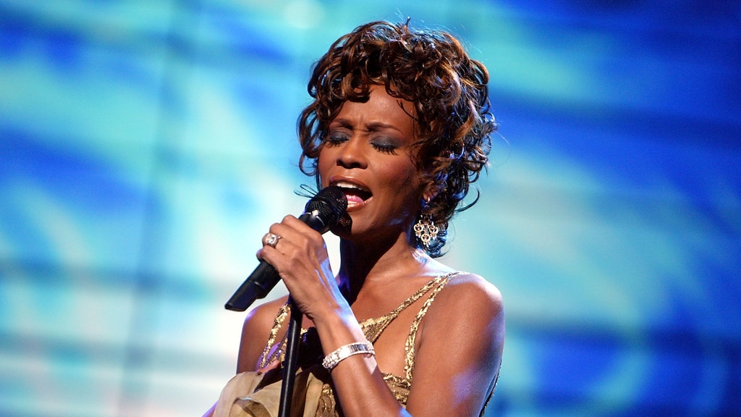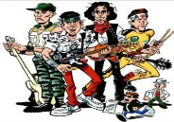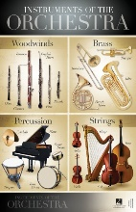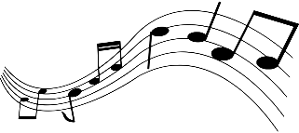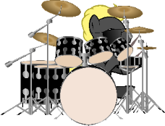<strong>Piano</strong> <strong>Keyboard</strong> Waves Card Free Stock Photo - Public Domain ...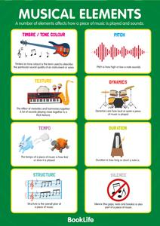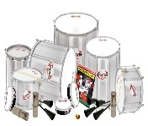<strong>Cartoon speaker</strong> by lemmling - A <strong>speaker</strong>.

**ARTS AWARD QUALIFICATION**

**Part A: Take part**

**Part B: Be in an audience (trip to London)**

**Part C: Arts Hero**

**Part D: Demonstrate**

**COMPOSING & PERFORMING**

**Developing solo and ensemble performances and BRIEF composition for NEAs using Focus On Sound and Sibelius * Mock Exam**

**AREA OF STUDY 2**

**THE CONCERTO**

**Understanding the concerto music devices, orchestra, composers for:**

**BAROQUE, CLASSICAL & ROMANTIC ERAS (trip to Abingdon School Concerto Day)**

**\* Mock Exam**

**COMPOSING & PERFORMING**

**Developing solo performances and own choice composition for NEAs using Focus On Sound and Sibelius * Mock Exam**

**AREA OF STUDY 3**

**RHYTHMS OF THE WORLD**

**Identifying historical context, instruments and music devices through listening, composing and performing**

**GREEK BHANGRA INDIA ISRAEL**

**PALESTINE**

**AREA OF STUDY 4**

**VIDEO GAME MUSIC**

**Listening, identifying instruments, composers, devices and music tech (trip to Sheldonian Theatre)**

**AREA OF STUDY 3**

**RHYTHMS OF THE WORLD**

**Identifying historical context, instruments and music devices through listening, composing and performing**

**SAMBA AFRICA CALYPSO**

**AREA OF STUDY 4**

**FILM MUSIC**

**Listening, identifying instruments, composers, devices (trip to Sheldonian Theatre)**

**AREA OF STUDY 5 CONVENTIONS OF POPULAR MUSIC**

**ROCK ‘n’ ROLL Building skills in listening, composing and performing**

**AREA OF STUDY 5 CONVENTIONS OF POPULAR MUSIC**

**ROCK ANTHEMS Building skills in listening, composing and performing**

**AREA OF STUDY 5 CONVENTIONS OF POPULAR MUSIC**

**Pop Ballads**

**Building skills in listening, composing and performing**

**REGGAE** **Identifying historical context, music devices and performers. Performing and composing Reggae music. Cross curricular link.**

**SKILLS BUILDING** **Intro to GCSE course. Area of Study 1: My Music Instrument project**

**BATTLE OF THE BANDS**

**Performing in an ensemble. Building CONFIDENCE, rehearsal CULTURE, Selected pieces are CHALLENGING and students will CELEBRATE during performances**

**BLUES MUSIC** **Identifying historical context, music devices and performers. Performing and improvising Blues music. Cross curricular link.**

**FILM MUSIC** - **Identifying film music devices, techniques, composers. Performing film music and composing to a trailer using GarageBand/WalkBand or Bandlab music tech.**

**INSTRUMENTS OF THE ORCHESTRA**

**Listening to and identifying Instrument Families, seating plan, performing on instruments. Listening to Classical pieces**

**RHYTHM & NOTATION**

**Developing reading and writing music skills performing and composing on Sibelius**

**BATTLE OF THE BANDS**

**Performing in an ensemble. Building CONFIDENCE, rehearsal CULTURE, Selected pieces are CHALLENGING and students will CELEBRATE during performances**

**SAMBA**

**Listening, composing and performing world music identifying musical features.**

**ELEMENTS OF MUSIC**

**Listening, performing the Elements and composing on Sibelius using technology skills**

**TRANSITION PROJECT Listening & Performing building the 4c’s**

Best work project

**A-Levels**

**Apprentices**

**University**