
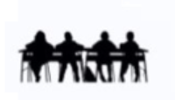
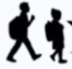
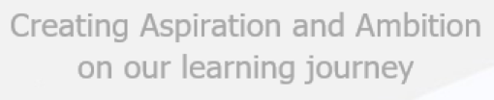

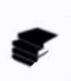
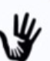
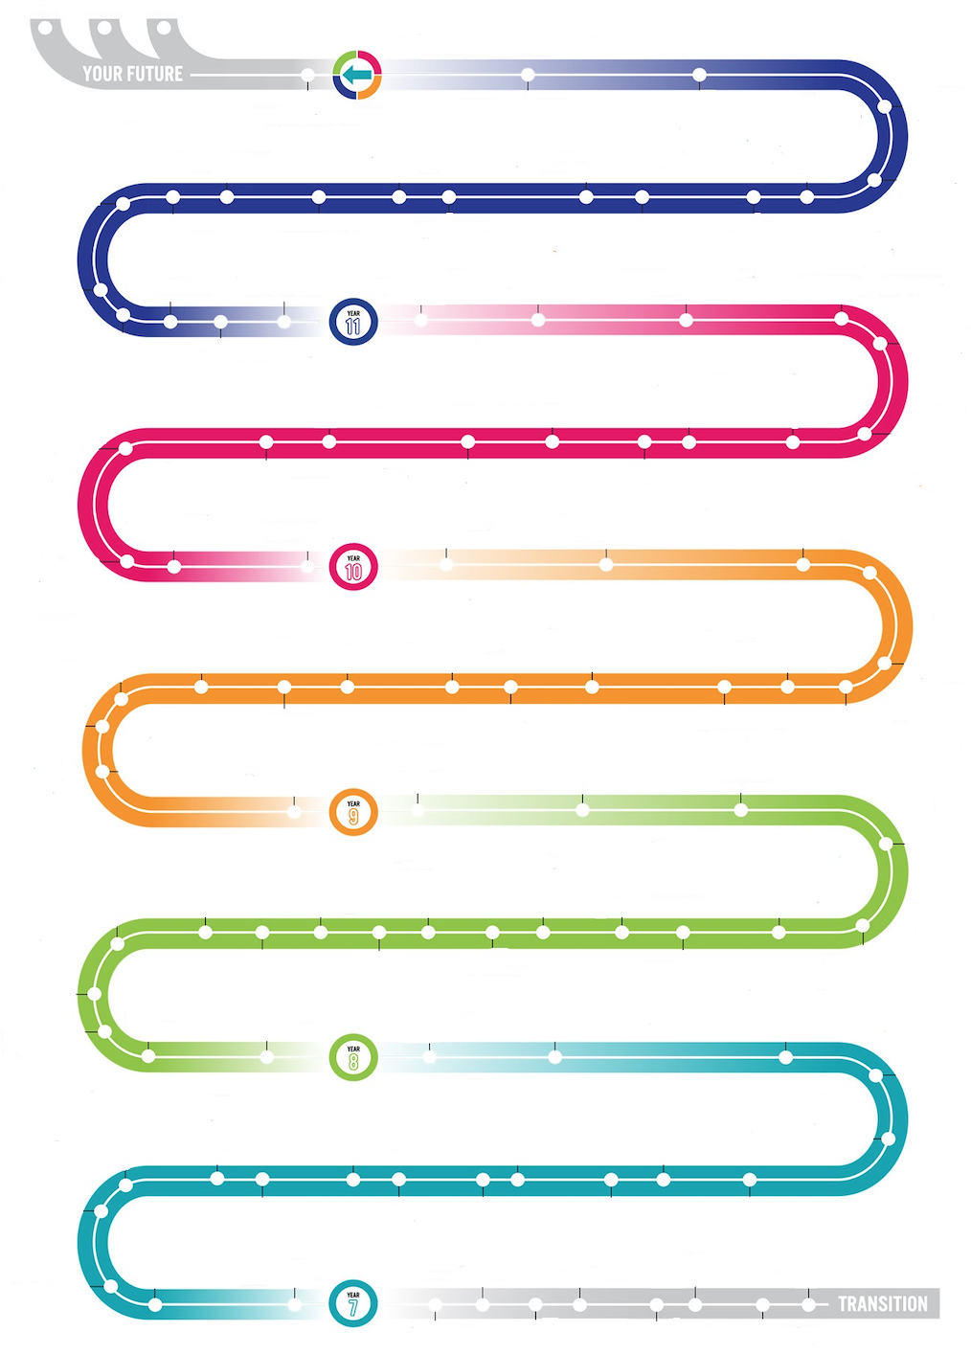
Technology Faculty
Product Design (Resistant Materials)

Metal Skills & Finishes Project

Yr7 RM: Aluminium key Fob, Bookmark/paperclip, Travel Game

Garden Product & Finishes Project

Maths for DT – Area, Volume, Fractions & Ratio, Units of Measurement

Mechanical Toy Project
(Cams/Followers & CAD/CAM)

Ergonomics & Finishes Project

Storage & Finishes Project

Drawing Skills & Preparation for NEA

Timber Skills Project

Timber Joints

Veneers / Laminating Project

CAD / CAM Skills

Specialism Theory - Timbers

Past & Present Designer Research

Year 12 & 13: Experience

UCAS pathways evening

Revision for core & specialism examination theory

Mock Exams

NEA – Section 3
Design Proposals

NEA – Section 2
Specification & Brief

NEA – Section 4
Making

Mock Exams

Year 9: Product Design (Timbers)

“Revision Cards” for Specialist theory

NEA Launch of
Contextual Challenge

NEA – Section 5
Evaluating

NEA – Section 1
Investigating / Research

“Revision Cards” for core theory

Yr8 Food: Fair trade, Sensory analysis, Calculating the cost of meals, Vegetarians and vegans, Organic food, DMT – fajitas, chilli con carne, rock cakes, pasta sauce, pizza

Cross-curricular links: Food with Maths, P&R, religion, ethics, and Biology - weighing and measuring, units, costing of recipes

Cross-curricular links: Product design with Science, computer science, and business – polymer chains, programming laser cutter, marketing products

Year 8 Options Evening; information linked to careers.

Yr8 Graphics: point of sale & Advertising, Structures, Isometric Drawing, Orthographic Drawing

Reaching out to partner schools we provide open days that introduce engaging inspiring curriculum tailored to individuals. Demonstrating a culture which allows creativity and confidence to grow through engaging in the design and make process e.g. Laser cut keyrings.
Yr7 Food: Ethical food production · Food - other cultures & religions, DMT – fruit salad, pizza toast, apple crumble etc., Apprentice project

Cross-curricular links: Textiles and VPA

Yr8 RM: Children’s Chocolate Moulds, Clock Design

Yr8 Textiles: Pop-Art Cushions

Yr7: Food hygiene & safety, Nutrition & healthy eating · Planning methods

Year 7 Literacy - Key words displayed on the wall in classrooms

Yr7 Textiles: Ugly Dolls/Puppets

Yr7 Graphics: Pop-up cards/Comic book Mechanisms, Crating/sketching, Oblique Drawing, Perspective Drawing;

KS3: Developing leadership, purposeful homework with a specific focus

Year 8 Literacy - Key words displayed on the wall in classrooms

