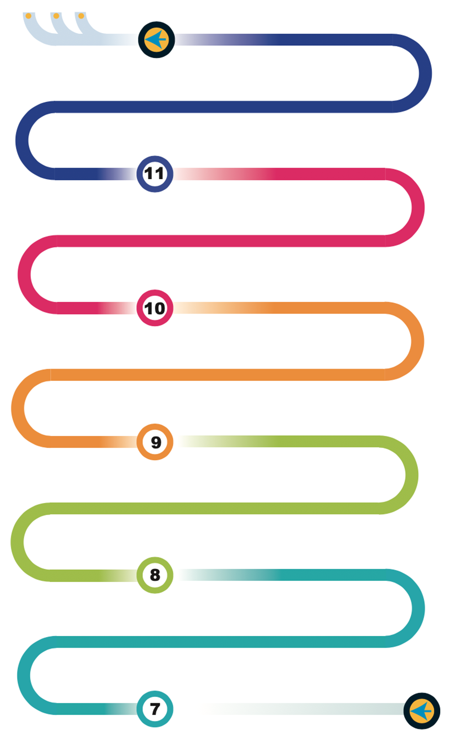















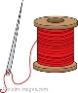




Cooking and Nutrition - Understand and apply principles of nutrition and health. Cooking repertoire of predominantly savoury dishes
Evaluate - Analyse a design and compare against past and present designers. Consider its impact on society and the environment
GCSE Coursework - 5 - Evaluation of the final product through testing against the original brief

Design Challenge:
This module looks at basic electronic circuit design and how to apply skills in electronics, woods metal and plastics to solving a creative design problem
Yr9 Homework: Review, revise and recall for the exam. Production of revision resources end of topic tests/mock exams.
Yr10 Homework: Review, revise and recall for the exam. Production of revision resources end of topic tests/mock exams.
GCSE Coursework - Section 3 - Design Proposals

Working with materials: Learning tools and techniques, properties and uses of woods and plastics
Paper and boards: Knowing and applying a range of mechanisms to appeal to a particular user
Food: Ethical food production, other cultures & religions, DMT.
Textiles: Understand the sewing machine, stitching techniques, templates, safety
Packaging design: Mould making, vacuum forming and understanding plastics properties.
Fair trade, Sensory analysis, Calculating the cost of meals, Vegetarians and vegans, Organic food, DMT

Maths in DT: how to apply maths principles to real world design problems which include gear ratios, mechanisms, areas and volumes

Food: Hygiene & safety, nutrition & healthy eating
Reaching out to partner schools : Engaging with design and make process

Review, revise and recall in preparation for the exam.
GCSE Coursework —Section 2 – Identifying the brief and writing a detailed specification
GCSE Coursework - Section 4 – Controlled assessment of the manufacturing of a final design

Term 6 - GCSE Coursework - Section 1 - Investigation of the Contextual challenge released
A Levels
Apprenticeships
University
Design: Research, Identify users needs, Develop a specification, Generate creative ideas
Technical Knowledge - Develop an understanding of materials and design techniques to prosuce a prototype
Make - Applying the use of Equipment, machinery, CAM and ingredients
Sketching techniques: Crating, Isometric, Oblique Drawing, Perspective Drawing
Understanding design movements and past and present designers
Textiles: Understand applique, sewing buttons and beads, smart textiles
Heath & Safety in Design and Technology
DT Theory - Focused delivery of theory through teaching and practice papers
Design & Technology start
Design & Technology - Electronics
Learning Journey
D&T Learning Journey
Graphics: Point of sale & Advertising, Structures, Isometric Drawing, Orthographic Drawing
Technical Design:
This module develops technical skills in CAD and laser cutting techniques. Detailed concepts around amplifier theory and Integrated circuit (IC) are taught to prepare students for designing their own circuits
NEA Preparation:
A series of short task to analyse previous years coursework, and create work to help guide through each stage, including assessment diagrams, pages map with a key, and creative investigation challenge.
Understanding circuits:
Module to help understand basic principle through breadboarding (mock ups) of key basic circuits. This includes understanding how to test for errors and use a multi-meter
Ergonomics:
Skills in designing for the comfort of others and those with disabilities: Incorporating metals and plastics
Core timber skills:
Timber working techniques while learning mechanisms such as cams and followers, joining techniques
KS3 Homework: Purposeful homework encouraging confidence and celebration.
D&T Learning Journey
Working with materials: Developing skills in metals, timbers and joining techniques

