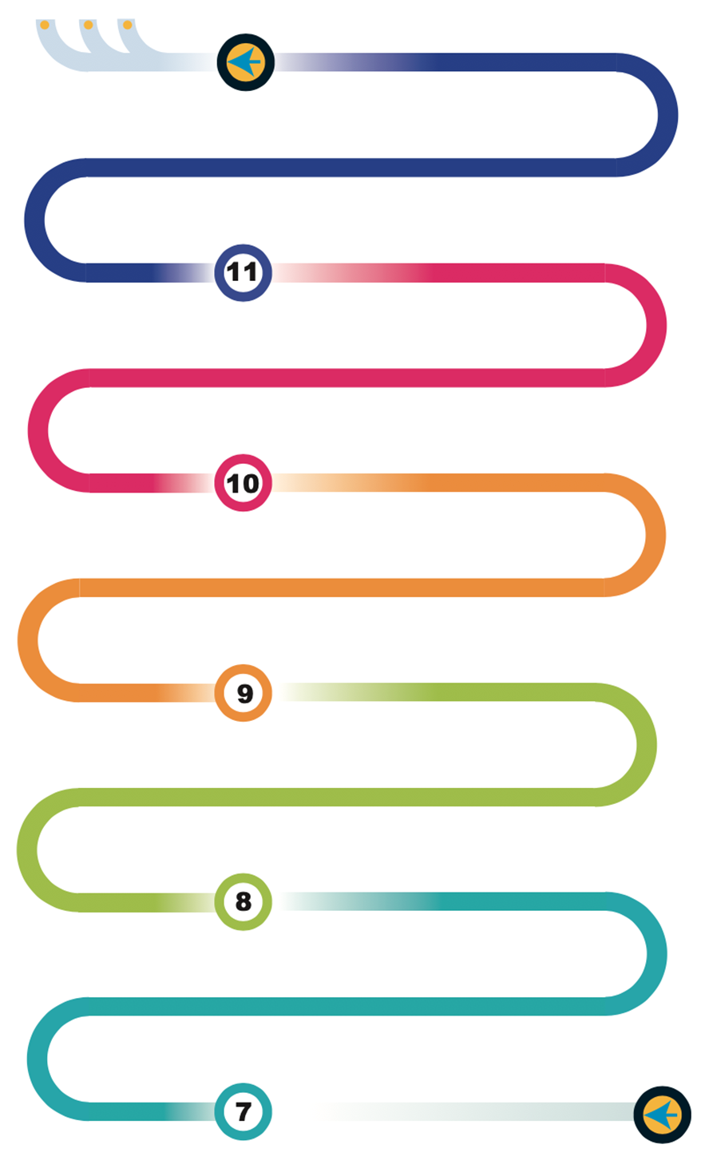



















GCSE Coursework - Section 3 - Design Proposals

Branding Design:
This module develops graphical and packaging skills with problem solving and CAD. Working with papers and boards for the packaging and a series of light/modelling materials for a prototype to be packaged
Design Challenge:
This module looks at basic electronic circuit design and how to apply skills in, woods metal and plastics to solving a creative design problem
Sustainability:
Skills in designing for a sustainable future using the 6 r’. Modelling materials Styrofoam, modelling woods, paint.
Packaging design: Mould making, vacuum forming and understanding plastics properties.
Technical Knowledge - Develop an understanding of materials and design techniques to prosuce a prototype
Evaluate - Analyse a design and compare against past and present designers. Consider its impact on society and the environment
GCSE Coursework - 5 - Evaluation of the final product through testing against the original brief

Food: Ethical food production, other cultures & religions, DMT.
Yr9 Homework: Review, revise and recall for the exam. Production of revision resources end of topic tests/mock exams.
Yr10 Homework: Review, revise and recall for the exam. Production of revision resources end of topic tests/mock exams.
Working with materials: Learning tools and techniques, properties and uses of woods and plastics
Paper and boards: Knowing and applying a range of mechanisms to appeal to a particular user
Textiles: Understand the sewing machine, stitching techniques, templates, safety
Fair trade, Sensory analysis, Calculating the cost of meals, Vegetarians and vegans, Organic food, DMT

Maths in DT: how to apply maths principles to real world design problems which include gear ratios, mechanisms, areas and volumes

Food: Hygiene & safety, nutrition & healthy eating
Reaching out to partner schools : Engaging with design and make process

Review, revise and recall in preparation for the exam.
GCSE Coursework —Section 2 – Identifying the brief and writing a detailed specification
GCSE Coursework - Section 4 – Controlled assessment of the manufacturing of a final design

Term 6 - GCSE Coursework - Section 1 - Investigation of the Contextual challenge released
A Levels
Apprenticeships
University
Design: Research, Identify users needs, Develop a specification, Generate creative ideas
Make - Applying the use of Equipment, machinery, CAM and ingredients
Sketching techniques: Crating, Isometric, Oblique Drawing, Perspective Drawing
Understanding design movements and past and present designers
Textiles: Understand applique, sewing buttons and beads, smart textiles
Heath & Safety in Design and Technology
DT Theory - Focused delivery of theory through teaching and practice papers
Design & Technology start
Design & Technology - Graphics
Learning Journey
D&T Learning Journey
Graphics: Point of sale & Advertising, Structures, Isometric Drawing, Orthographic Drawing
NEA Preparation:
A series of short task to analyse previous years coursework, and create work to help guide through each stage, including assessment diagrams, pages map with a key, and creative investigation challenge.
Core papers and boards skills:
Packaging: folding techniques, structural use of card, printing, Laser cutter.
KS3 Homework: Purposeful homework encouraging confidence and celebration.
D&T Learning Journey
Cooking and Nutrition - Understand and apply principles of nutrition and health. Cooking repertoire of predominantly savoury dishes
Ergonomics:
Skills in designing for the comfort of others and those with disabilities: Incorporating timbers and soft metals
Working with materials: Developing skills in metals, timbers and joining techniques

