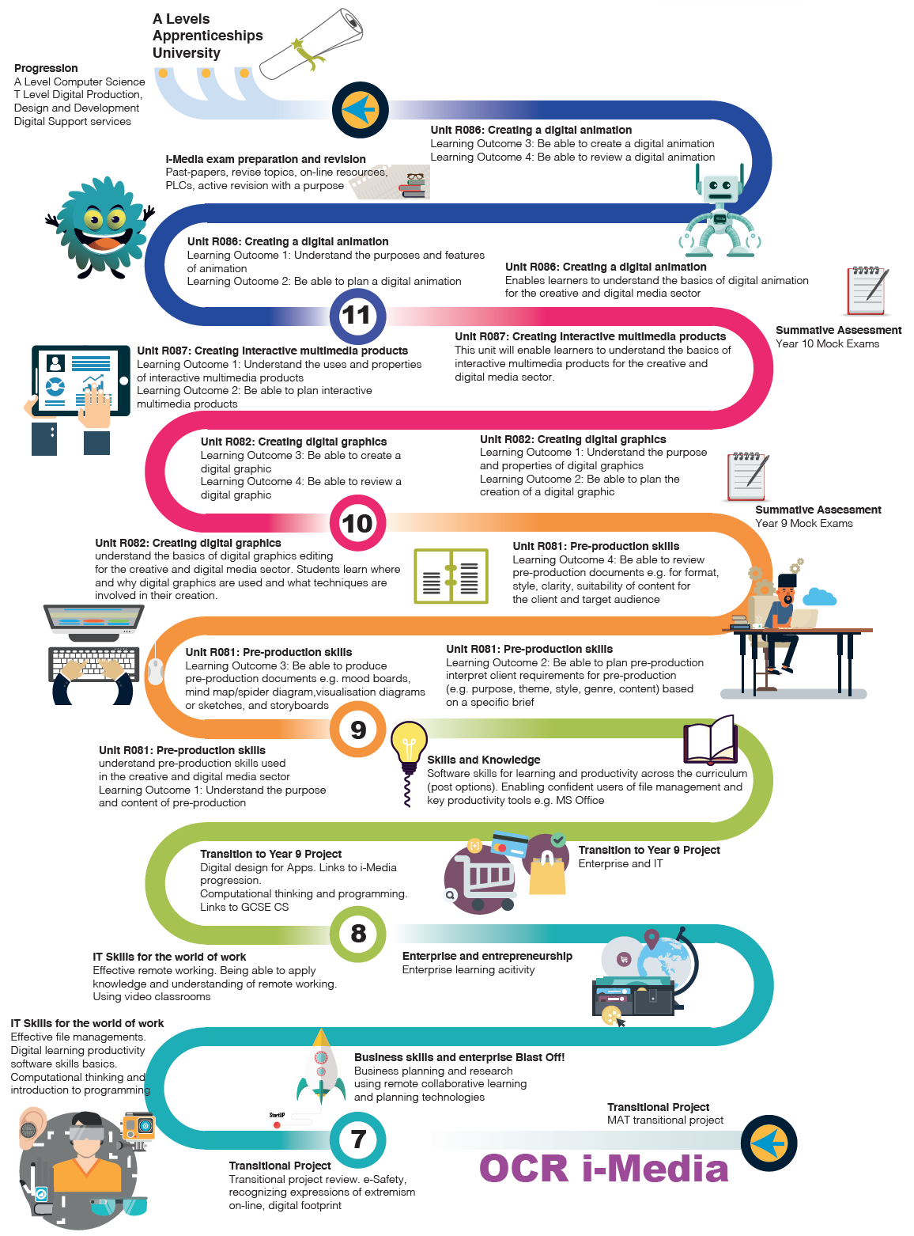


OCR I-Media


Best work project

