
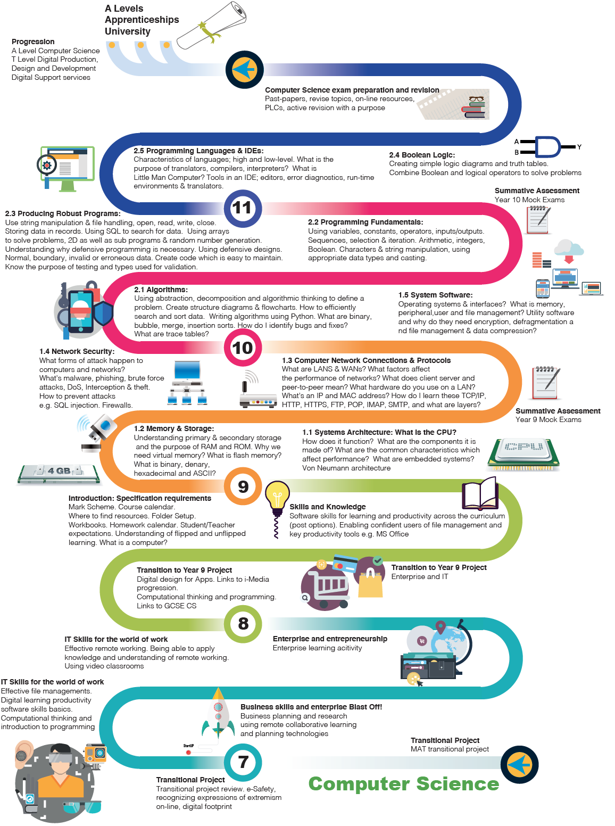

Computer Science


Best work project

