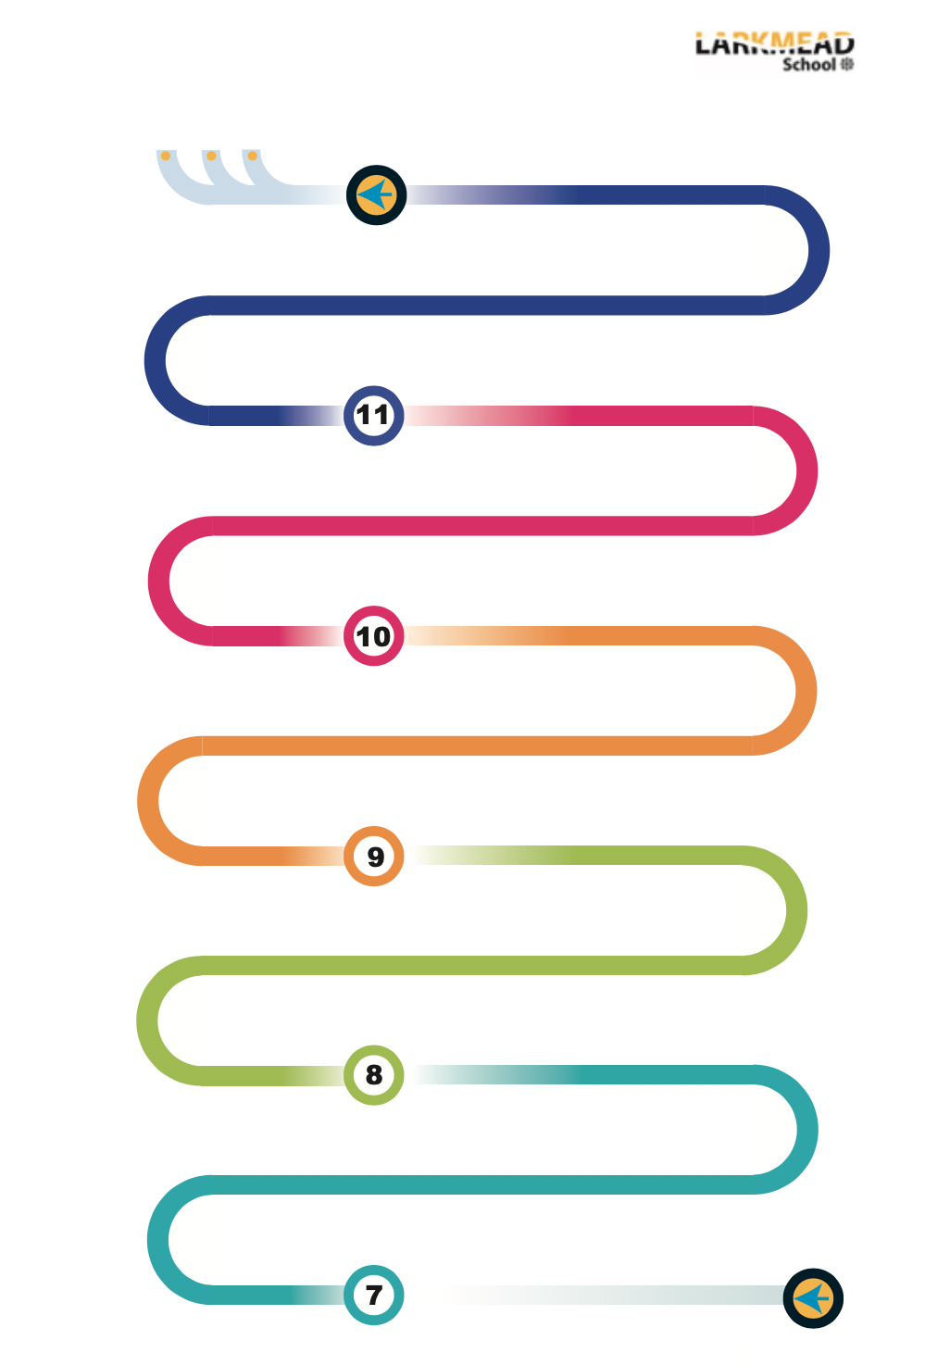
Links to Further Education:
A Level Media Studies, A Level Film Studies /Film / Media BTEC courses (not available at Larkmead), Degree / Higher education courses in screenwriting, film and TV, Media Studies. Apprenticeships within industry settings








Core practical experience:
Storyboarding, use of cameras, editing experience, working to a brief. Group organisation and team management

Set text 1: Contemporary British Film (Skyfall)
Visual style, franchise conventions, British Film, representations, film form analysis

Non-Examination Assessment:
Research of genre conventions, planning of either filmed extract or screenplay / shooting script extract. Shooting / editing or writing followed by evaluation
Set text 3: Component 2, Section B - Global non-English film (Tsotsi)
Analysing representations, Film Form, context

KS3: Developing leadership, purposeful homework with a specific focus

Reaching out to partner schools we provide open days that introduce engaging inspiring curriculum tailored to individuals. Demonstrating a culture which allows creativity and confidence to grow through engaging in the design and make process e.g. Laser cut keyrings.
Best work project
Cross-curricular links: Food with Maths, P&R, religion, ethics, and Biology - weighing and measuring, units, costing of recipes

Year 7 Literacy - Key words displayed on the wall in classrooms

Yr7 Food: Ethical food production · Food - other cultures & religions, DMT – fruit salad, pizza toast, apple crumble etc., Apprentice project

Yr7: Food hygiene & safety, Nutrition & healthy eating · Planning methods

Yr7 Graphics: Pop-up cards/Comic book Mechanisms, Crating/sketching, Oblique Drawing, Perspective Drawing;

Cross-curricular links: Textiles and VPA

Yr7 Textiles: Ugly Dolls/Puppets

Yr7 RM: Aluminium key Fob, Bookmark/paperclip, Travel Game

Cross-curricular links: Product design with Science, computer science, and business – polymer chains, programming laser cutter, marketing products

Year 8 Literacy - Key words displayed on the wall in classrooms

Yr8 Graphics: point of sale & Advertising, Structures, Isometric Drawing, Orthographic Drawing

Yr8 RM: Children’s Chocolate Moulds, Clock Design

Yr8 Textiles: Pop-Art Cushions

Year 8 Options Evening; information linked to careers.

Yr8 Food: Fair trade, Sensory analysis, Calculating the cost of meals, Vegetarians and vegans, Organic food, DMT – fajitas, chilli con carne, rock cakes, pasta sauce, pizza

Year 9: Film Studies option begins:

Core Concepts:
Film form knowledge, terms and analysis – camera, lighting, editing, sound, Mise en Scene

Core Concepts:
History of film – key dates and developments. Trends and technologies. Knowledge acquisition

Core Concepts:
Narrative, representation, industry
Theory, analytical practice. Structuring written responses

Core practical experience:
Screenplay conventions, creating narrative, character, setting. Practical practice
Year 10 & 11: Experience

Set text 2: Global English Language Film (Slumdog Millionaire)
Narrative structure analysis, Film Form analysis, context

Cross-curricular links: History (context, history of film), English Literature (analytical skills, written response structure), Photography (framing and use of the camera, lighting), IT (use of software), Performing Arts (structuring and planning narratives, characterisation, setting, acting in filmed extract responses)

Literacy - Key words displayed on the wall in classrooms and glossaries within workbooks

Aspirational career choices

UCAS pathways evening

Year 12 & 13: Experience

Set text 4 & 5: US film comparative study (Singin’ In The Rain and Grease) Analysing representations, genre conventions, Film Form, context, narrative and comparing texts.

Set text 6: US Independent film (Me, Earl and The Dying Girl). Analysing Film Form, representations, industry context, applying critical writings, developing viewpoints.

Technology Faculty – Film Studies

A-Levels
Apprentices
University

