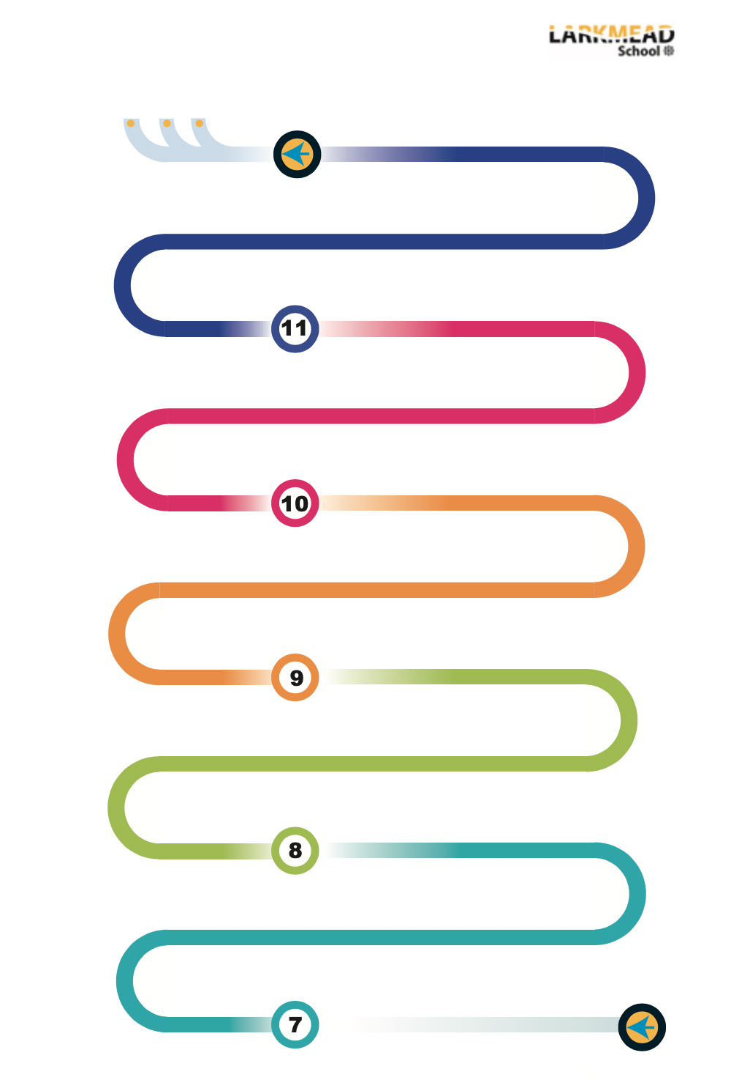

Yr7 RM: Aluminium key Fob, Bookmark/paperclip, Travel Game

Year 8 Options Evening; information linked to careers.

Yr8 Graphics: point of sale & Advertising, Structures, Isometric Drawing, Orthographic Drawing

Cross-curricular links: Textiles and VPA

Yr8 RM: Children’s Chocolate Moulds, Clock Design

Yr8 Textiles: Pop-Art Cushions

Year 7 Literacy - Key words displayed on the wall in classrooms

Yr7 Textiles: Ugly Dolls/Puppets

Yr7 Graphics: Pop-up cards/Comic book Mechanisms, Crating/sketching, Oblique Drawing, Perspective Drawing;

Year 8 Literacy - Key words displayed on the wall in classrooms


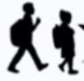

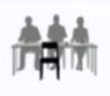

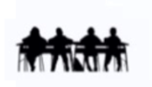

NEA 2: worth 35%

Term 2: Mock GCSE written exam
End of topic tests

Topic: Food Science
Bread-making
Raising agents
Year 9: Experience:

Topic: Food Hygiene

End of topic tests
Year 10: Experience

Reaching out to partner schools we provide open days that introduce engaging inspiring curriculum tailored to individuals. Demonstrating a culture which allows creativity and confidence to grow through engaging in the design and make process e.g. Laser cut keyrings.
Cross-curricular links: Food with Maths, ethics, and Biology - weighing and measuring, units, costing of recipes

Yr7 Food: Hygiene and safety, planning recipes, designing dishes, nutrition, weighing and measuring, equipment, ethical food production.

Yr7 Food: DMT – fruit salad, pizza toast, apple crumble etc., Apprentice project
KS3: Developing leadership, purposeful homework with a specific focus

Best work project
Cross-curricular links: Product design with Science, computer science, and business – polymer chains, programming laser cutter, marketing products

Yr8 Food: Fair trade, Sensory analysis, Calculating the cost of meals, Vegetarians and vegans, DMT – fajitas, chilli con carne, rock cakes, pasta sauce, pizza

Theory and practical lessons linked to theory topics

Yr9 Food: Development of 12 main practical skills

Eggs Cake-making
Cooking methods
Pastry-making
Sauce-making

Meat and fish
Dairy products
Cereals and carbohydrates
Heat transfer

“Revision Cards” for key words

Topic: Food Provenance

Theory and practical lessons

Topic: Food, Nutrition and Health

Term 3: Mock GCSE written exam
Topic: Food Choice

Yr10 Food: Continuing development of 12 main practical skills

Walking Talking Mock Exams
Mock NEA 1
Year 11: Experience

NEA 1: worth 15%

Aspirational career choices

Written exam: 50%

Walking Talking Mock Exams
UCAS pathways evening

Technology Faculty - Food & Nutrition

A-Levels
Apprentices
University

