



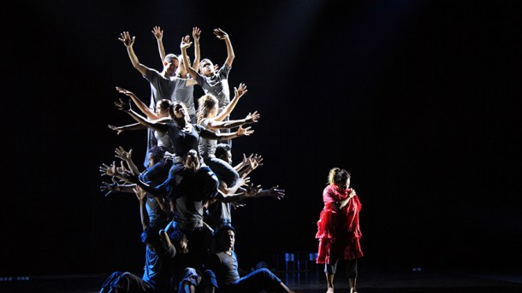

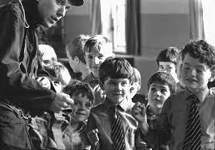

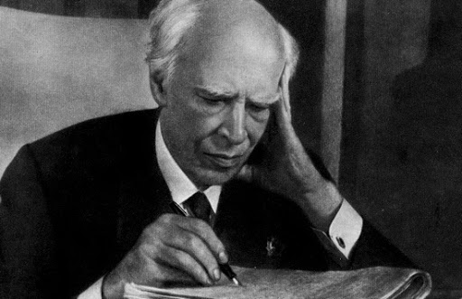
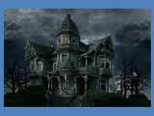
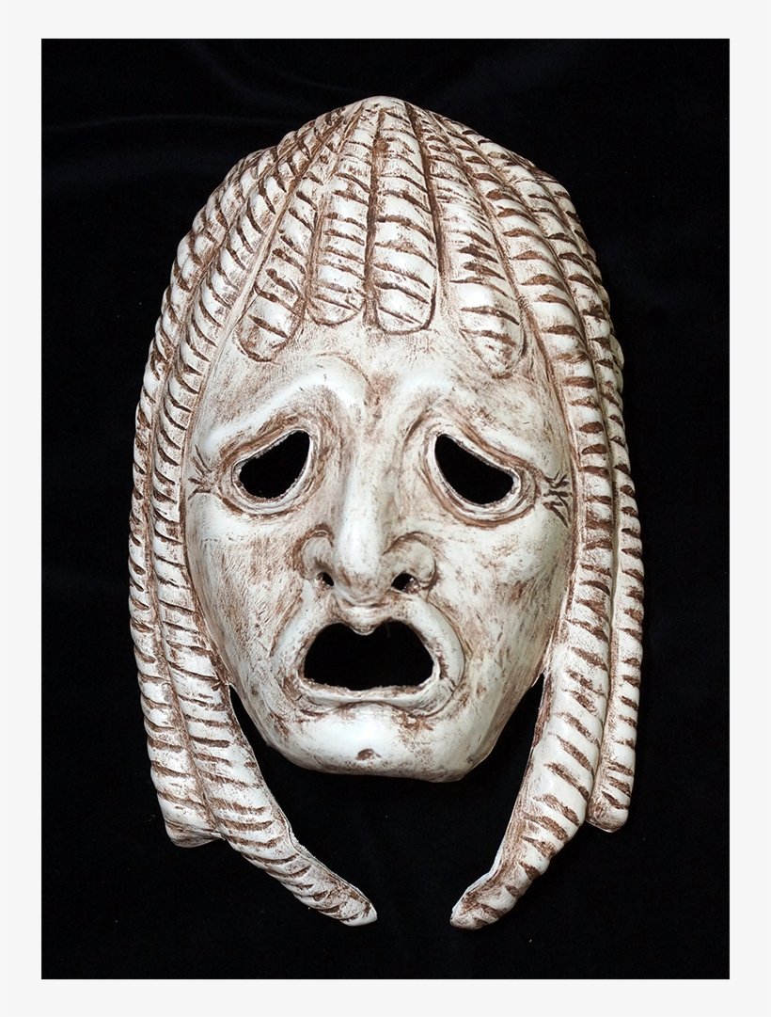



Year 12 / 13:
Cambridge technical – Level 3 – performing arts
A-Level Performing Arts
Apprentices
University
Exam preparation
Performing from a text – NEA 2 - Exam
Performing from a text – NEA 2
Preparing for the written paper
Live theatre review
Theatre visit
Interpreting theatre – Set text
Devising – NEA – Component 1 - exam
Devising – NEA – Component 1
Professional workshop
Brecht – political theatre
Influence of theatre practitioner
Becoming a critic
Interpreting theatre
Introduction to set text
Monologues, duologues
Performing text
Influence of theatre practitioner
Introduction to Emma Rice- & kneehigh - Applying style and techniques to Hansel and Gretel
Devising using Physical theatre,
Influences of
Frantic assembly/ Dv8/Punch drunk
Influence of genre
Technical theatre, Staging, Lighting, Sound, props & costume.
Design
Arts trip to London
Arts Award
Interpreting theatre
Page to stage part 2. Interpreting text. Actor. Director
Theatre in education
Stranger danger
Developing rehearsal techniques

Influence of genre
Devising techniques: Responding to stimulus- applying Stanislavski method. Flashbacks/forward. Monologues/ direct address
Devising for performance
Cultural Arts Day - Year 8
Introduction to Shakespeare
Performing from a text
Cultural Arts Day – Year 7
Devising techniques
Storytelling & Improvisation Skills.
Narrative, direct address
Page to stage, part 1
exploring text, duologues
Interpreting theatre
Influence of theatre practitioner
Introduction to Stanislavski
Devising
Creating Atmosphere
Through the door,
When a girl goes missing.
Darkwood manor.
Pantomime Visit
introduction to vocal and physical skills
Teddies talk & Greedy King

Trust exercises, teamwork,
drama skills, Simple Devising techniques
Historical Influences
Rehearsal & Devising skills.
Mime, thought tracking,
Split staging, hot seating
Theme - bullying
Devising
Influence of genre
Commedia dell’Arte mask work, creating scenarios.
Best work project
Developing basic staging skills.
Character interpretation, motivation and empathy. Set text
Introduction to Drama
Developing Character
Interpreting text
Greek theatre – Choral work & Greek mythology
Drama

