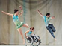

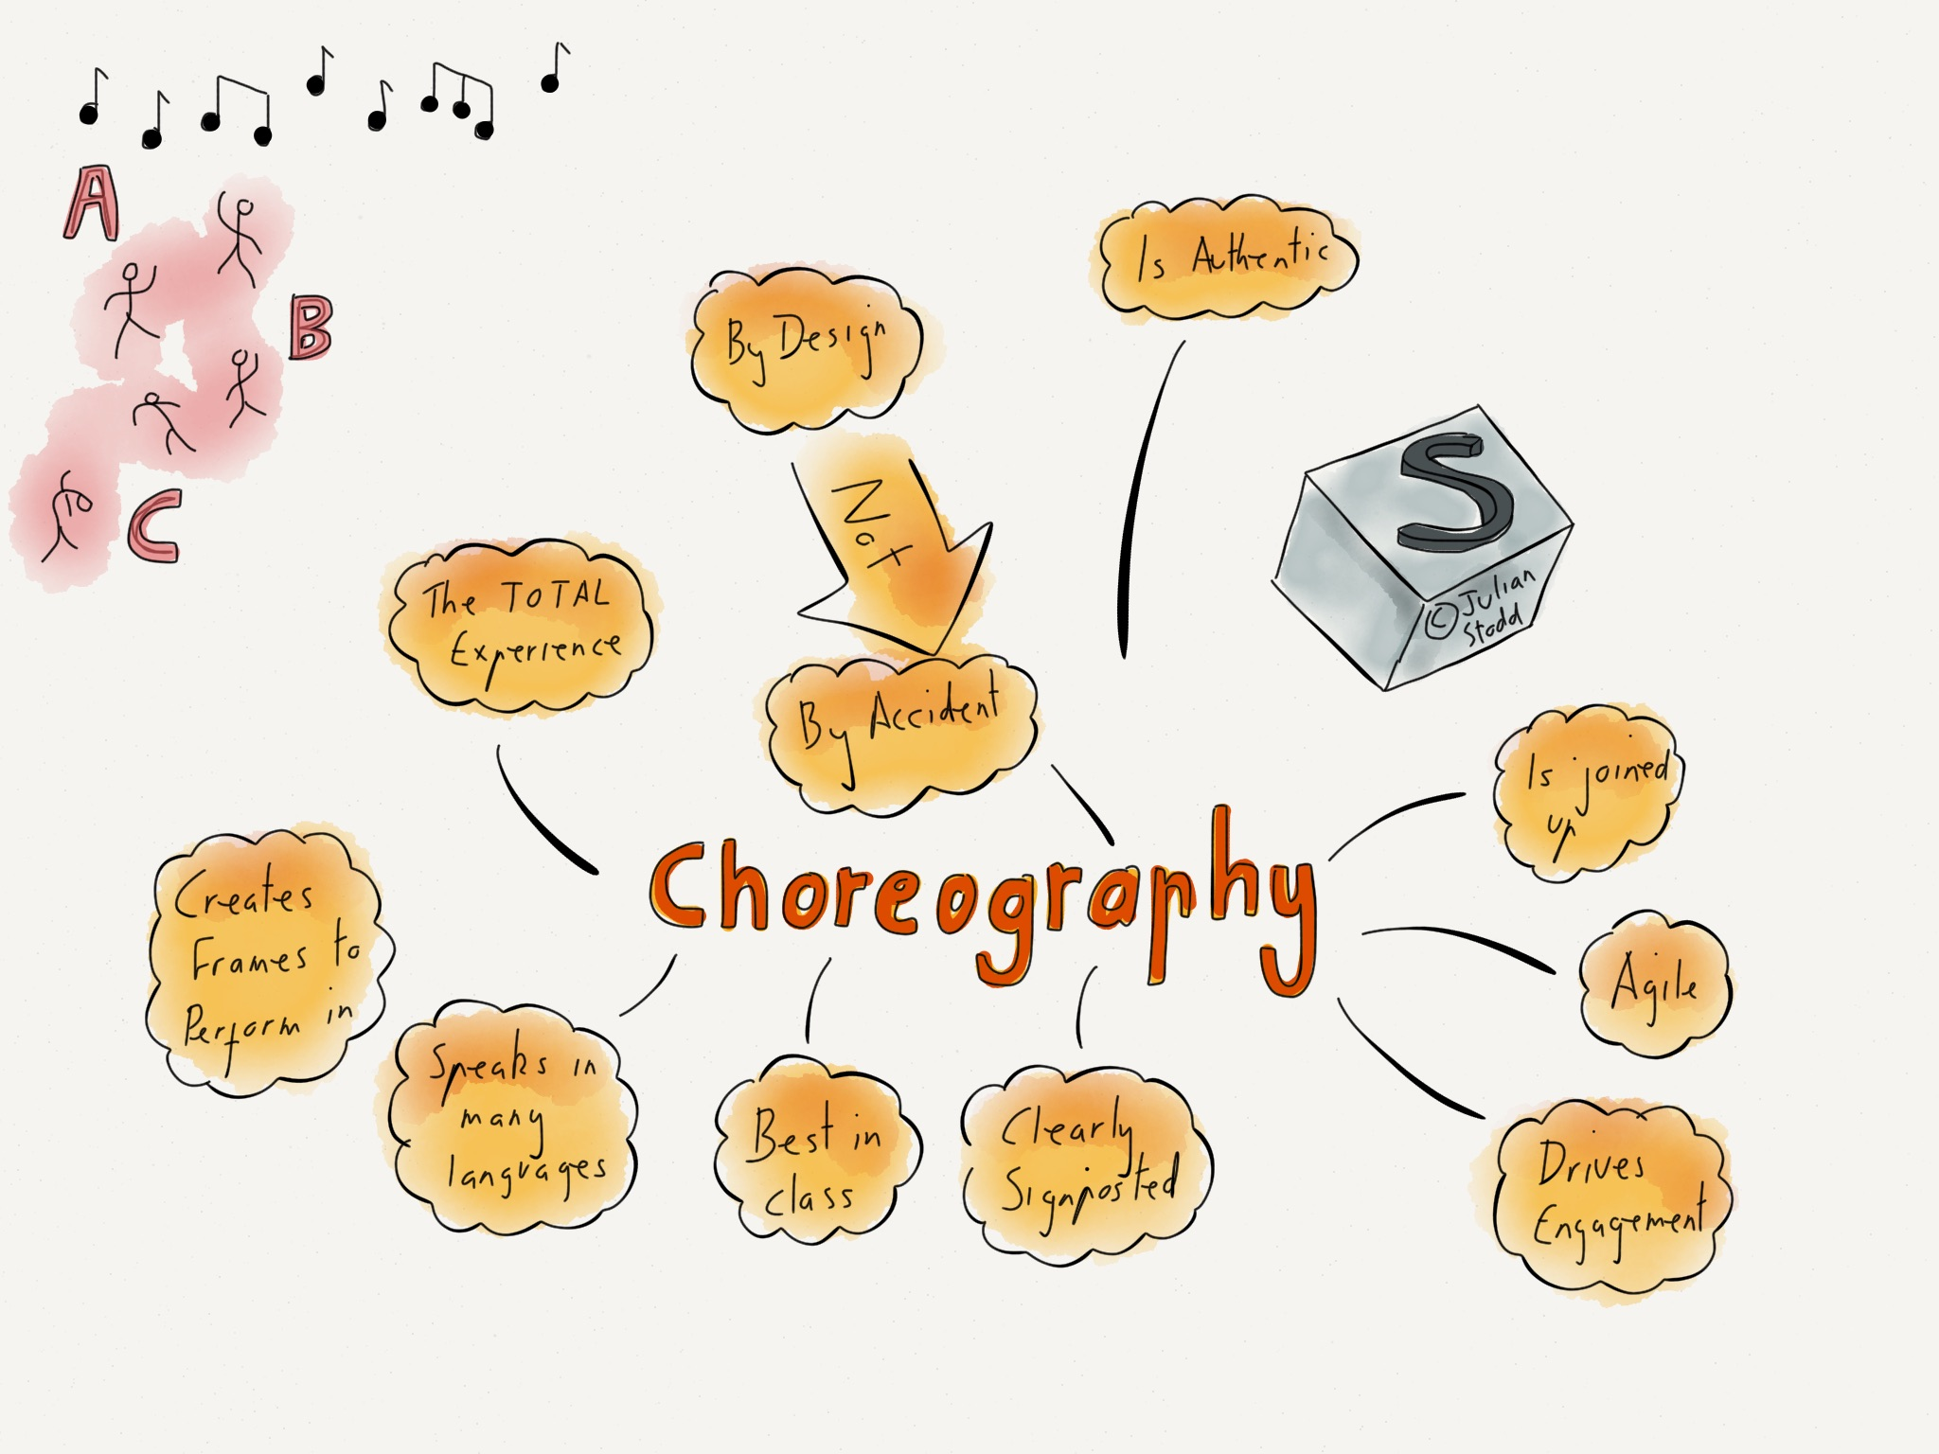

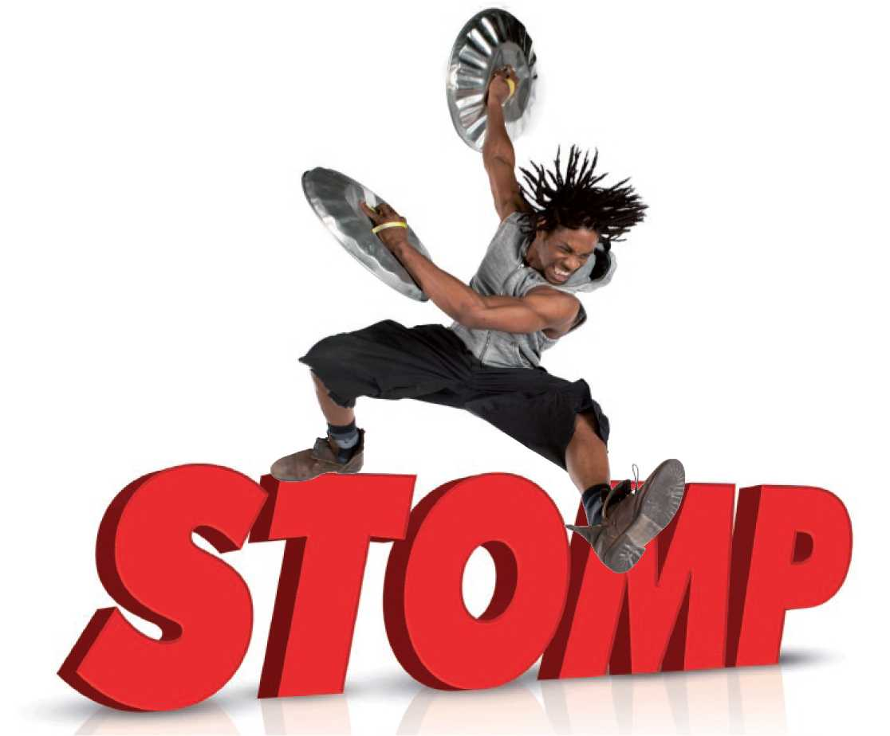
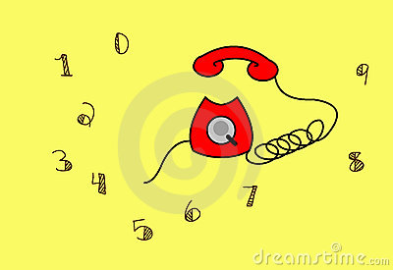
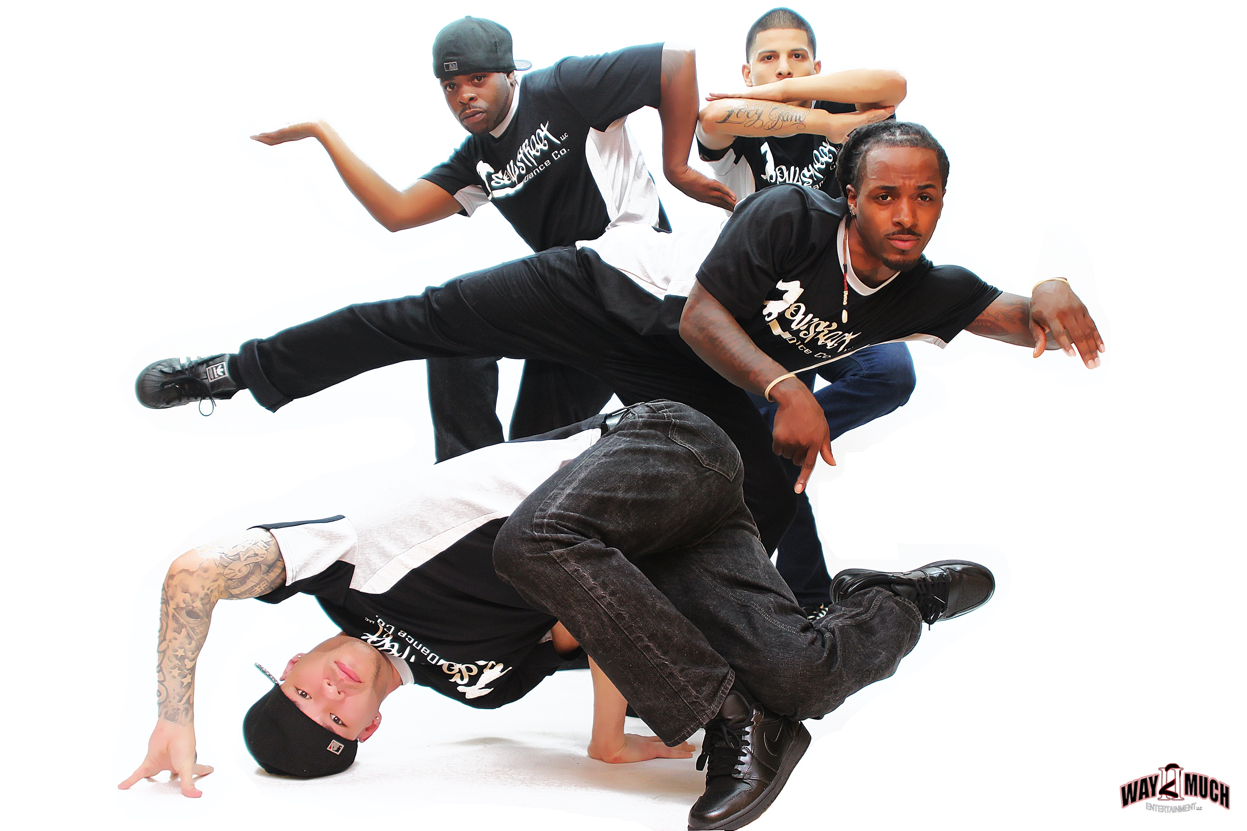
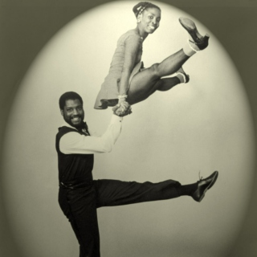
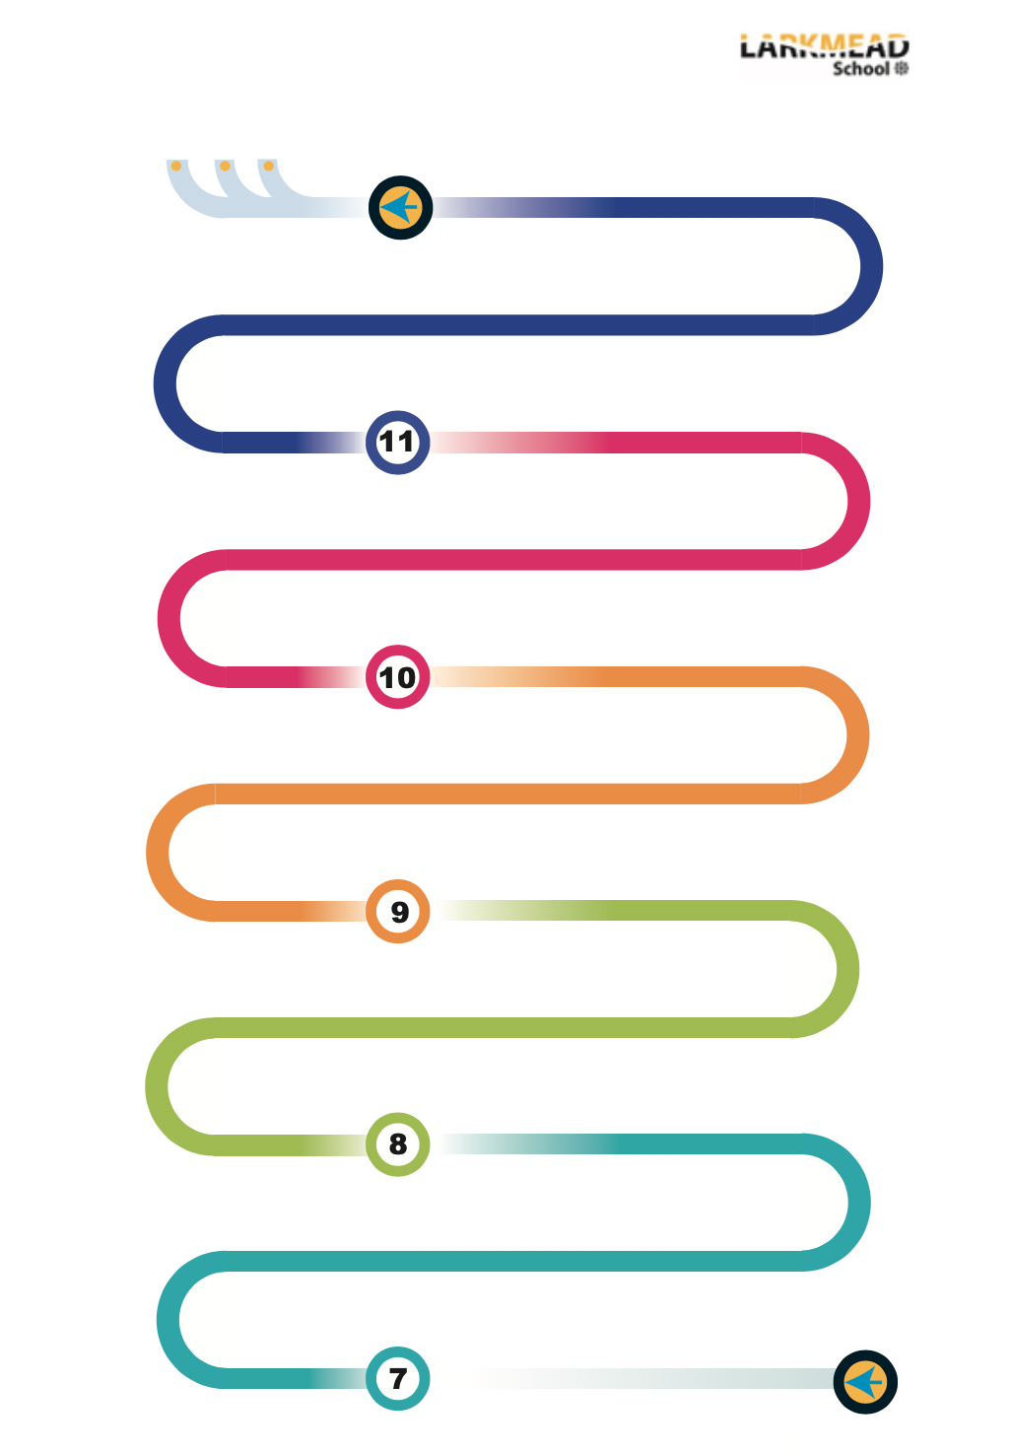
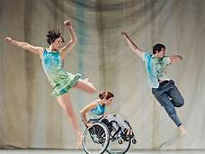
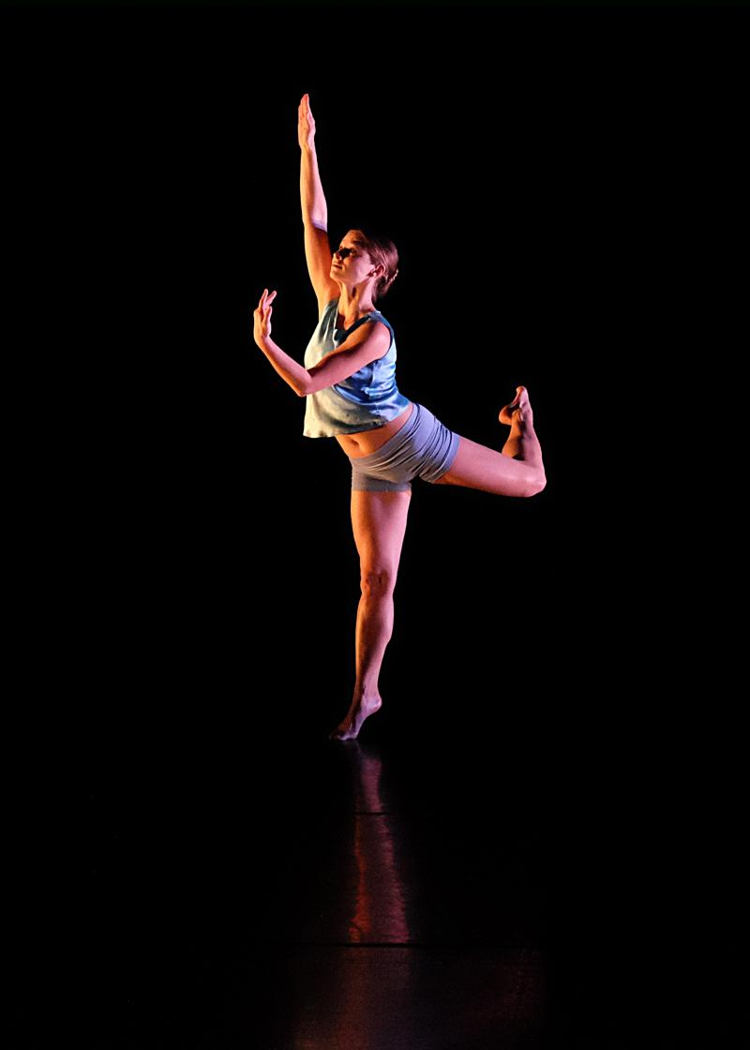
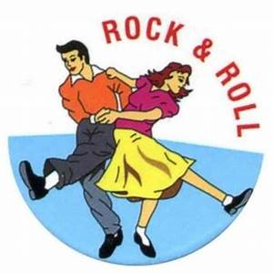
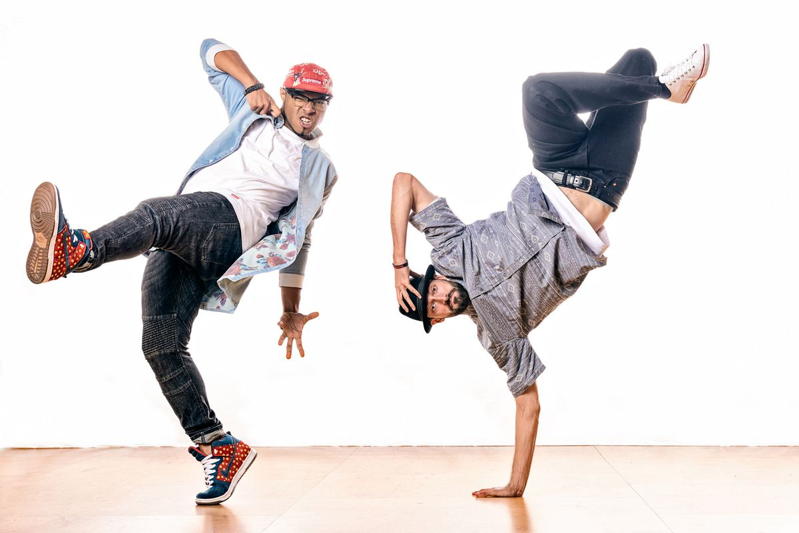
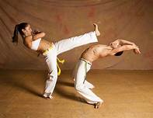



Lindy Hop
The Journey
World War 2
Evacuees/ Refugees
Stomp
Dancing Rhythms
Dancing Telephone Numbers
& Introduction to Dance
Introduction to dance – Using dance and number (code) to create choreography
Dance/Mathematics
Street Dance
Exploring Pop culture and Street Dance and the history of Iconic Street artists Choreographic and performance skills
Dance/Art
Professional work 5/6
Analysis and understanding of the production features and dance
features of the work and their contributions
Begin for GCSE Performance in duo/group – identify motif development
through process – safe practice- performance skills
Refine choreography using feedback from dance Fest
in prep for interim examination February
focus on section A of exam paper
GCSE examination – completion of practical 60%
Choreography exam paper arrives mid-September. Explore questions and workshop ideas.
Develop 1st draft of choreographies for mock exam assessment
in dance Fest
Develop 1st draft of choreographies for mock exam assessment
in dance Fest
Dance Fest – mock examination
Recap study and more in depth study of professional works across the year
Set Phrases Examination At Christmas
during mock exam period.
Written examination
Begin work on Performance in duo/trio. Assessed
on performance skill and communicating choreographic
intention. Focus on section B of exam paper
Observation and analysis – dance
Criticism composite elements and production features
Performance skills & Safe practice:
(Sharing of work – dance fest – costume?) GCSE criteria introduced for performance.
Professional work 3 /4
Analysis and understanding of the production features and dance features of the work and their contributions
Choreography Assessment using criteria
Performance piece 1
Practical and theory assessment
(Section B & section C + practical assessment)
Study of professional work
Practical and theory assessment
(Section B & section C + practical assessment)
Practical and theory assessment
(Section B & section C + practical assessment)
Choreography –
What is required at GCSE? Solo choreography
Developing choreography – stimulus and how to use – solo choreography –
provide range of stimulus) ASD, devices, form, structure, aural setting etc.
choreography criteria.
Performance skills, Motif development, Types of stimulus
What, why, how and improving performance skills.
Introduction to GCSE
Choreography project
Introduction to professional workss
Revision of year –
Mock written paper section A & B
Introduction to professional works
Key dance skills Why and how to improve, safe dance practice
Working towards performance
Dance style – Exploration of dance styles in professional works at GCSE. Introduction to types of stimulus for choreography.
Workshops on features of styles and choreography
Contemporary, Hip Hop, Neo classicism, Samba, Capoeira, Site sensitive dance, Developing choreographic skills.
Choreography Skills
Performance Skills
Performance Skills
Dance technique –
baseline assessment
Dance technique –
baseline assessment
Performance skills
Introduction to choreography and motif development
Key dance skills: Taught motifs and short phrases to develop. Improvisation techniques to create movement.
. Development from year 7 street dance, Freestyle, improvisation and creating music video – popular culture – platforms for street dance.
Practical & Written summative term 1& 2assessment performance skills and motif development (section A)
Dance Fest!
Introduction to contact- Bullying and conflict
Exploring Lindy Hop culture and dance style, Where it came from – who was doing it and its place now – social dance. Technique and performance Dance/History
Rock N Roll: Exploring key styles of dance from 1950’s Social dance
Focus on key features of the style, seeing professional works, developing duet choreography. Contact, lifts, in hold and target key actions. Dance/History.
Preparation for GCSE Dance
Using a professional work Swan Song – Christopher Bruce
Exploring human rights. Enter Achilles – DV8
The Car Man Matthew Bourne
Preparation for GCSE Dance
Using a professional work Swan Song – Christopher Bruce
Exploring human rights. Enter Achilles – DV8
The Car Man Matthew Bourne
Preparation for GCSE Dance
Using a professional work Swan Song – Christopher Bruce
Exploring human rights. Enter Achilles – DV8
The Car Man Matthew Bourne
Rock ‘n’ Roll – the 1950s.
The Twist, Jitterbug, Jive
American Bandstand
Street dance - culture and music videos/dance for camera
Capoeira – style based Brazil Brazilian Culture Background to the style – Slavery. Exploration of style and development – acquisition of target language and action. Dance/MFL/Geography/History
Exploring the issues of conflict and bullying through contact work and use of narrative in dance. Exploring improvisation and choreography. Dance/PSHE/Drama
Study of professional work –Stomp, Exploring rhythm, sound and movement.
Analysis of professional work. Use of props. Dance/History/English
Exploring WW2 and the life of children – Evacuees
What did they do? What was it like? Where did they go?
Responding to range of stimuli. Dance/History/English
Introduction to choreography and motif development
Key dance skills: Taught motifs and short phrases to develop. Improvisation techniques to create movement.
Practical & Written summative term 1& 2assessment performance skills and motif development (section A)
Choreography project
Revision of year –
Mock written paper section A & B
Dance Fest!
Performance skills, Motif development, Types of stimulus
What, why, how and improving performance skills.
Introduction to GCSE
Performance skills & Safe practice:
(Sharing of work – dance fest – costume?) GCSE criteria introduced for performance.
Observation and analysis – dance
Criticism composite elements and production features
Study of professional work
Practical and theory assessment
(Section B & section C + practical assessment)
Performance piece 1
Choreography skills
Introduction to professional works
Choreography –
What is required at GCSE? Solo choreography
Developing choreography – stimulus and how to use – solo choreography –
provide range of stimulus) ASD, devices, form, structure, aural setting etc.
choreography criteria.
Professional work 3 /4
Analysis and understanding of the production features and dance features of the work and their contributions
Choreography assessment using criteria
Begin for GCSE Performance in duo/group – identify motif development
through process – safe practice- performance skills
Professional work 5/6
Analysis and understanding of the production features and dance
features of the work and their contributions
Choreography exam paper arrives mid September
Explore questions and workshop choreographic ideas
Develop 1st draft of choreographies for mock exam assessment
in dance Fest
Recap study and more in depth study of professional
works across the year
Dance Fest – mock examination
Set Phrases Examination At Christmas
during mock exam period.
Refine choreography using feedback from dance Fest
in prep for interim examination February
focus on section A of exam paper
Begin work on Performance in duo/trio. Assessed
on performance skill and communicating choreographic
intention. Focus on section B of exam paper
GCSE examination – completion of practical 60%
Written examination

