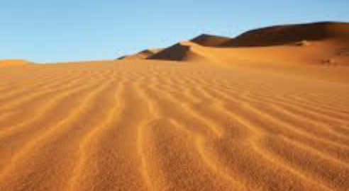
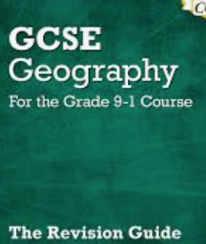
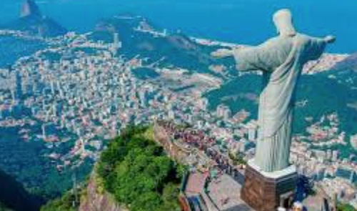
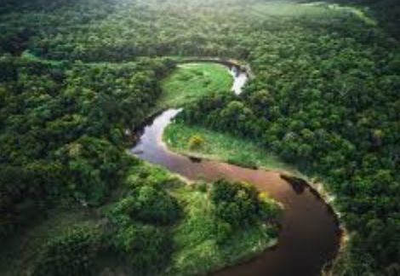
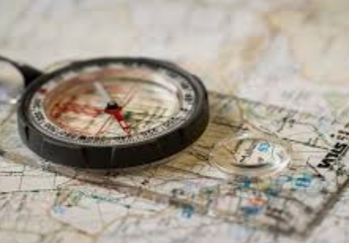
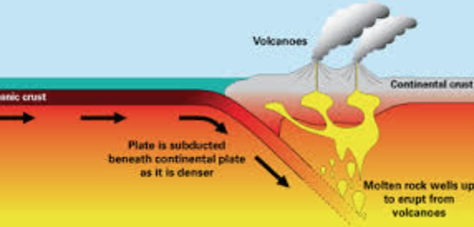
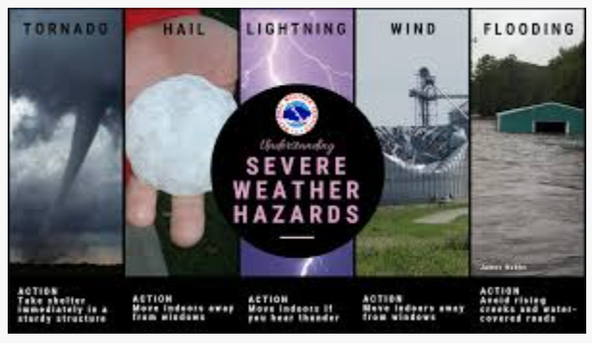
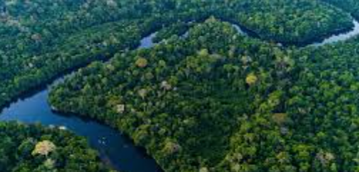
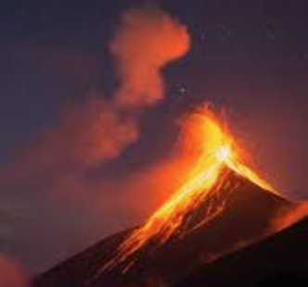
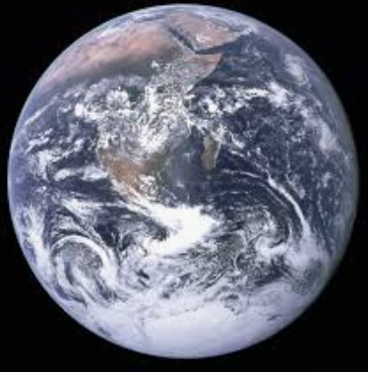

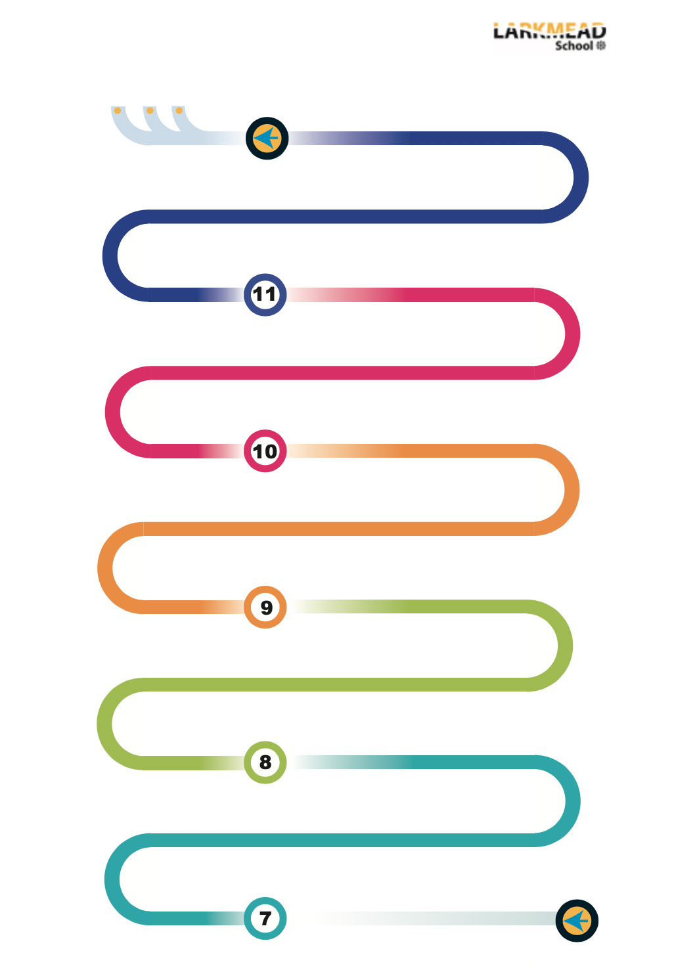

What are the causes and effects of weather hazards?
What are the urban issues and challenges in Bristol and Rio De Janeiro?
Why is Rio de Janeiro an important city and how is it changing?
What are the physical characteristics of rainforests and deserts and how have humans impacted on these ecosystem?

Where do our clothes come from and how are they impacting the climate?

What is climate change and how do we limit the consequences of climate change?

What hazards are caused by meteorological events?

How can we manage our resources?
How to solve geographical issues.
Year 12/13: Taster session – A level themes - Geo-political issues. Globalisation. Superpowers. Human rights and intervention.
EXAMS
WTM
Exam preparation
Mocks
Feedback
How has the use of resources changed over the years?
How have humans impacted on the availability of water?
Problem solving skills
Statistics
Geographical Enquiry
How has the economy in the UK and Kenya changed over time and why?
Evaluative skills
How have humans and climate change impacted on deserts and rainforest ecosystems?
How have humans impacted on rivers and coasts?
Recap Year 9
What are the physical processes of rivers and coasts?
What is Geography?
What are the characteristics of deserts and rainforests?
Collaborative skills
How do rivers work?
Big Picture:
Cause and effect
What are the causes and effects of tectonic hazards?
How will climate change impact on weather hazards?
Problem solving skills
Evaluation skills
Big picture:
The impact of human behaviour

Research skills
Comparative skills Enquiry skills empatheticem
Analytical skills
Evaluation skills
Comparative skills Enquiry skills empatheticem
Research skills
Geographical Investigation
What hazards are caused by tectonic activities?
Mapping Skills
Best work project
A-Level Geography
Apprentices
University
Year 10 Exam
Pulling it together
Practice
Revision skills - analysis
Exam skills
Modelling GCSE responses
Independent GCSE responses
Map Skills
engagement
Analytical skills

Multiple writing opportunities
Induction day
Geography

