
ART
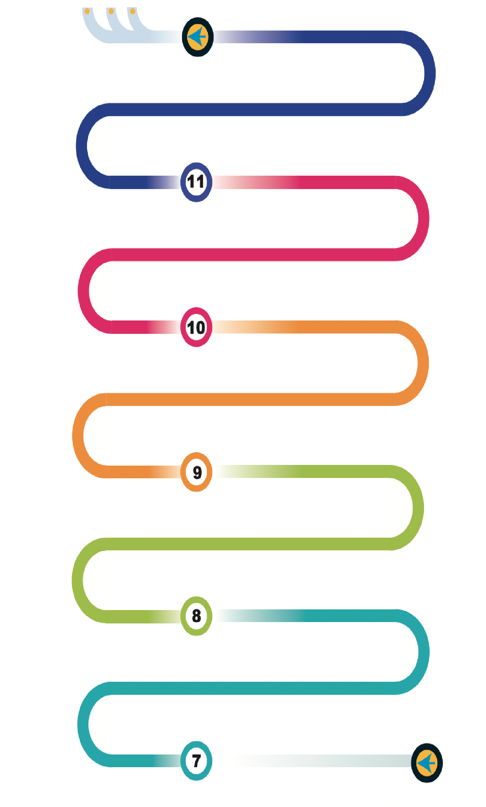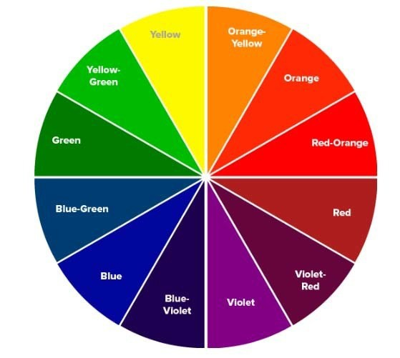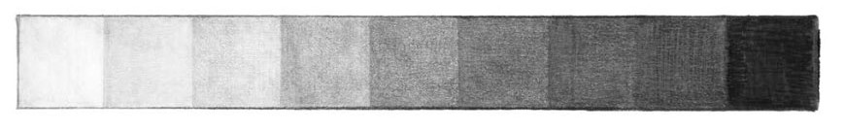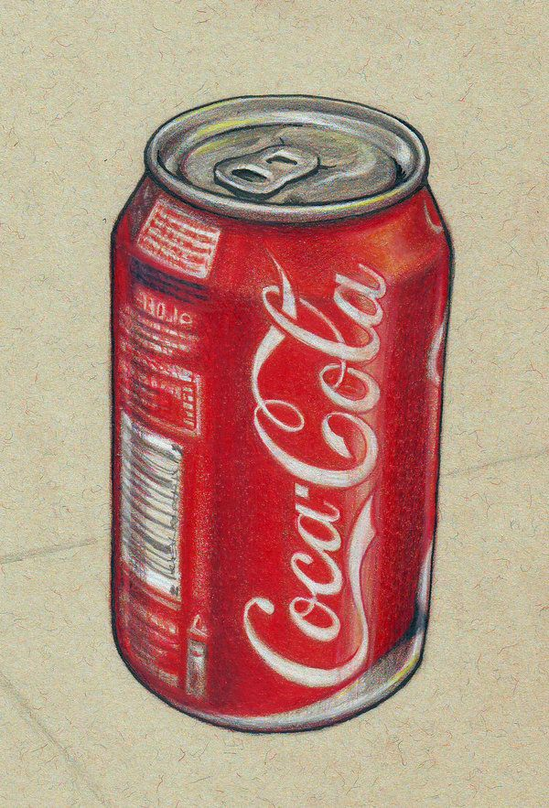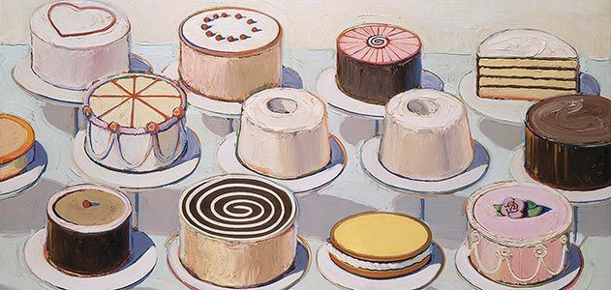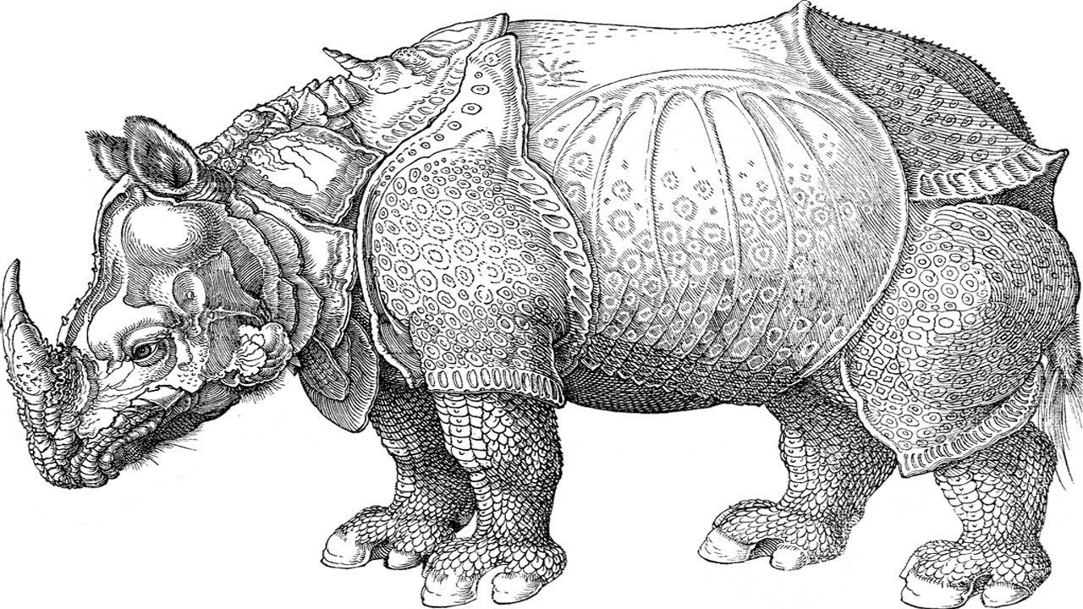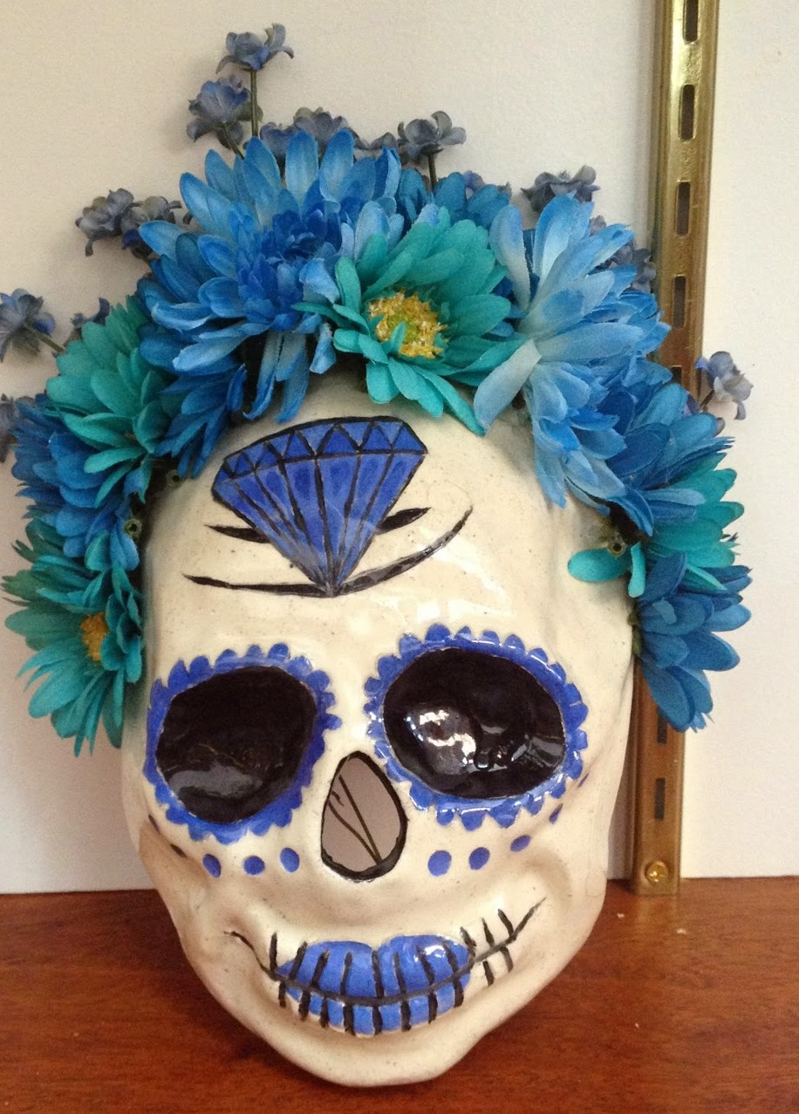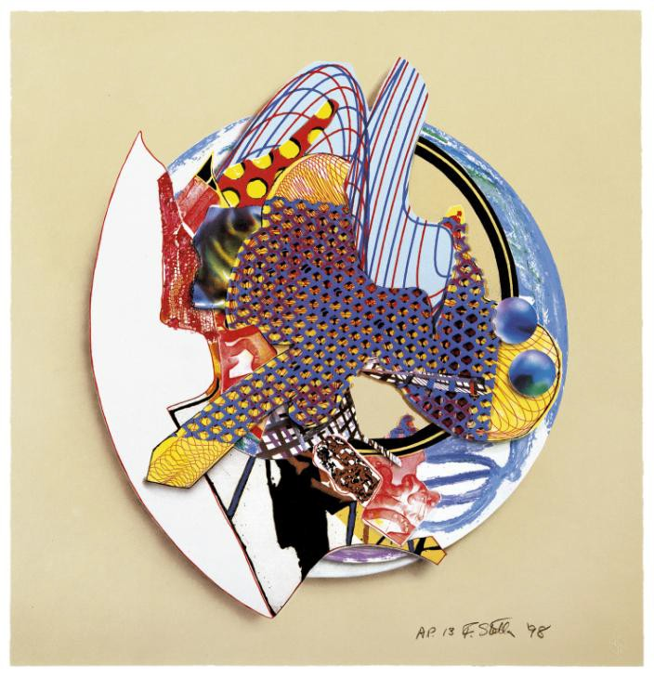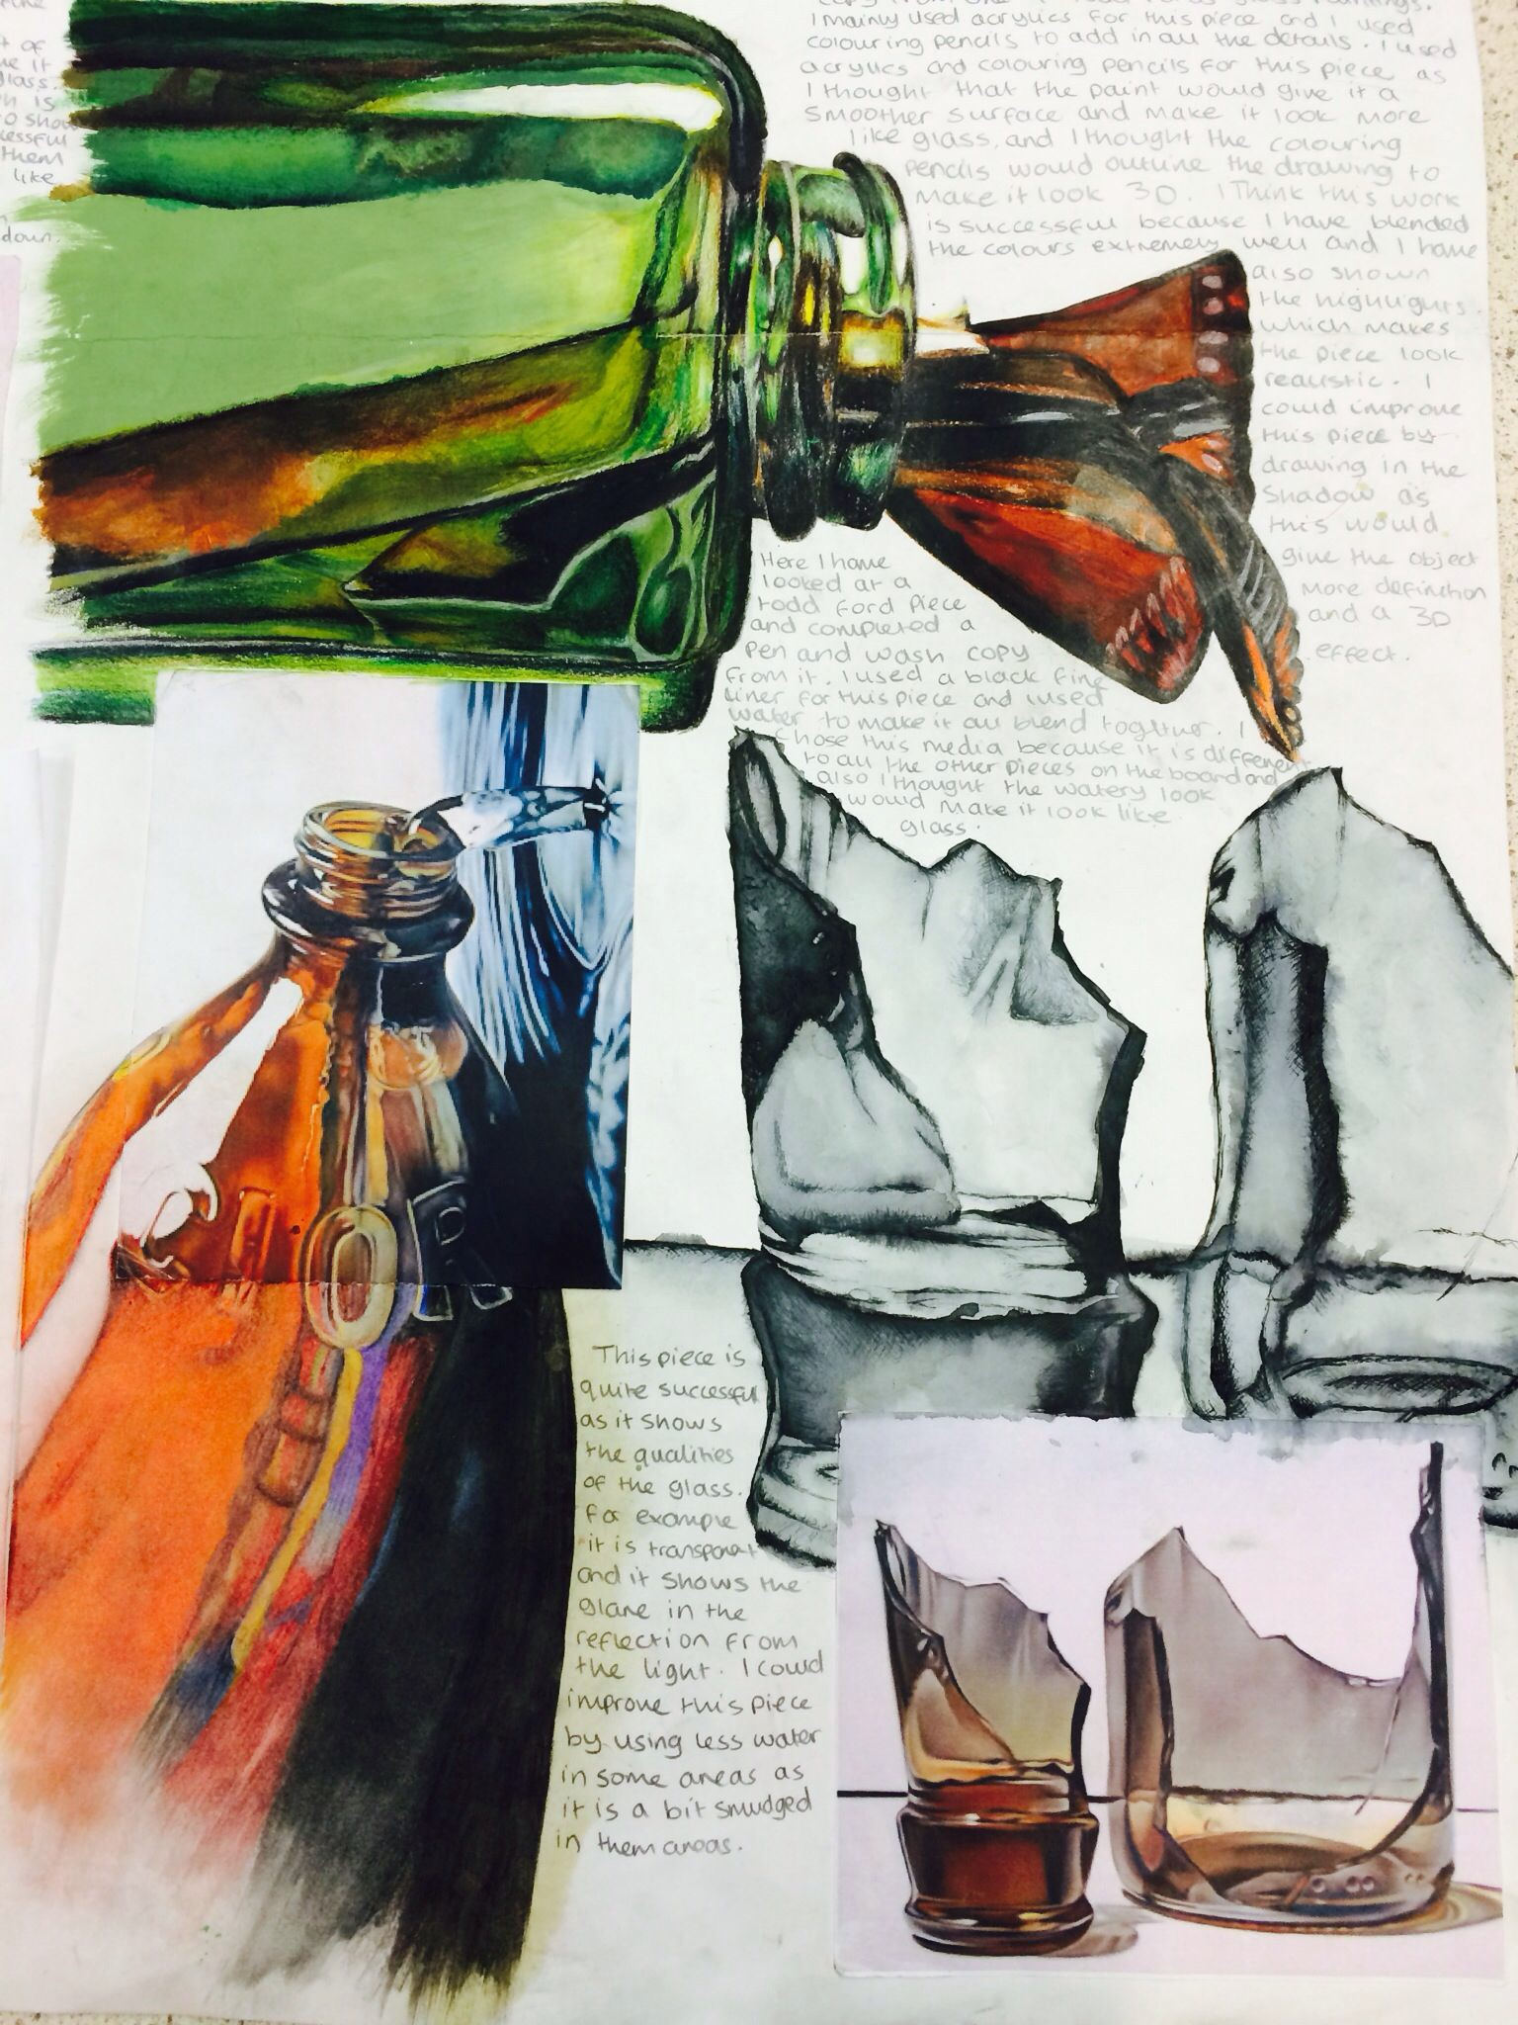
JUNE:
ART MODERATION
EXHIBITION OF STUDENTS WORK
JANUARY: EXAM PAPER GIVEN

Extra curricular catch up club & Interventions

ART MOCK EXAM: LINKED TO THEMATIC
THEMATIC PROJECT: (CHANGES YEAR TO YEAR) EG: EXTRAORDINARY/ORDINARY OR OPEN & CLOSED

EXTENDED FROM WORK COMPLETED DURING THE SUMMER

JANUARY: COURSEWORK UNIT ENDS

Exam Preparation

Developing Ideas

RECORDING IDEAS
REVIEW, REFINE, MODIFY, EVALUATE
APPLYING the assessment objectives
A01, A02, A03 , A04
Extra curricular catch up club & Interventions
APRIL: ART EXAM 10 HOURS
CREATING FINAL
PIECE

PROJECT

Sustained investigation:

SURFACES UNIT COMPLETED
SUMMER PROJECT

RECORDING IDEAS
APPLYING the assessment objectives
A01, A02, A03 , A04
‘SMALL THINGS’ PROJECT
SURFACES UNIT
Work in sketchbooks Exploring layout and design
Developing observational skills using a range of media and techniques looking at different surfaces such as reflective, rough, sharp, spiky.
Links to artists
EXPERIMENTAL DRAWING UNIT
Animal theme: textures and surfaces
Using different media & techniques
Exploring processes and materials
Researching Artists Analysis of own & others work
Painting techniques Perspective, angles & viewpoints Drawing 3D shapes and using form
Using tone to create form
Links to artists

DEVELOPING IDEAS

FRANK STELLA PROJECT
REVIEW, REFINE, MODIFY, EVALUATE
PERSONAL RESPONSE
MOCK EXAM 5 HOURS
Exploring abstract shapes Developing ideas
Using a range of processes and techniques Mixed media
Design ideas Personal response
Extra curricular catch up club & Interventions
Final outcome using artist links

SUMMER PROJECT

ABSTRACT SCULPTURE UNIT
Exploring artists Drawing form Artist focus
Experimenting with materials and surfaces
3D form and structures
Constructing and connecting materials

Arts Award & Trip
REVIEW, REFINE, MODIFY, EVALUATE

ANNOTATIONS
CULTURAL UNIT
Exploring different cultures Historical references and research Pattern and decoration
Embellishments Observational drawing Painting techniques 3D work
Embellishment and reliefs
Extra curricular catch up club

DEVELOPING IDEAS

RECORDING IDEAS
EXPLORING MATERIALS DEVELOPING IDEAS RESEARCHING ARTISTS
ANALYSIS OF OWN AND OTHERS WORK GENERATING DESIGN IDEAS
PERSONAL RESPONSE INDEPENDENT CHOICES SHARING IDEAS CREATING
VIEWPOINTS
Understanding the assessment objectives A01, A02, A03 , A04
PERSONAL RESPONSE

MINI SKILLS WORKSHOPS OFFERED
OUTLINE OF EXPECTATIONS DISCUSS THE ASSESSMENT OBJECTIVES AND MARKING CRITERIA OPENLY

GAINING SOME KNOWLEDGE OF ASSESSMENT OBJECTIVES
DEPENDENT RESEARCH
EXPANDING ARTIST VOCABULARY
WRITING CRITICAL STUDIES
YEAR 8 OPTIONS EVENING
Work displayed in class & open evening and on school social media
GCSE STYLE SKETCHBOOK PAGES & LAYOUT
2nd Baseline Drawing Task: Observational drawing.
Identifying progress & skills

Postcards home – positive praise
INTRODUCTION TO THE POP ART MOVEMENT
DEVELOPING SKILLS OBSERVATIONAL DRAWING PAINTING TECHNIQUES NEW MEDIA EXPERIMENTS MIXED MEDIA
3D SCULPTURE
Cross- curricular day

GCSE STYLE OUTCOME

ANALYSING ARTISTS WORK
ANALSING OWN WORK AND TECHNIQUES

THEMATIC PROJECT:FABULOUS FOOD
Years 7 & 8 OPEN EXHIBITION
Show in January
Landscape & Perspective 1-point perspective Viewpoints
Angles
Technical drawing skills Links to artists
Baseline Drawing Task: Observational drawing. Identifying prior skills from yr 7 and knowledge of Formal Elements and technique
Cross- curricular day
Self Portrait skills and techniques: proportion, structure, features, technique

FORM
Developing knowledge of making objects look 3D – applying line & tone

Postcards home – positive praise

TEXTURE SHAPE
2nd Baseline Drawing Task: Observational drawing of shoe. Identifying developed skills, progress and knowledge of Formal Elements and technique
Extra-curricular Art club
10 minute drawing tasks:
Lessons begin with observational drawings using different techniques to gain confidence

Using mark making and

COLOUR
PATTERN

Developing knowledge of different types of pattern. Applying pattern with different cultures.

TONE

Tonal scales, shading, shadows & highlights
media techniques to create texture
Introduction to Formal Elements: Specifically set tasks for each Formal Element to be explored and to gain confidence in techniques, materials and processes

LINE
Gaining knowledge of how line is used in various forms. Key focus is observational drawing
How shape is used to create art work.
Introduction to artists such as Henri Matisse
Introduction to colour theory and colour relationships. Stude
develop painting skills a techniques
nts nd

Baseline Drawing Task: Observational drawing. Identifying prior skills and knowledge of Formal Elements and technique

