





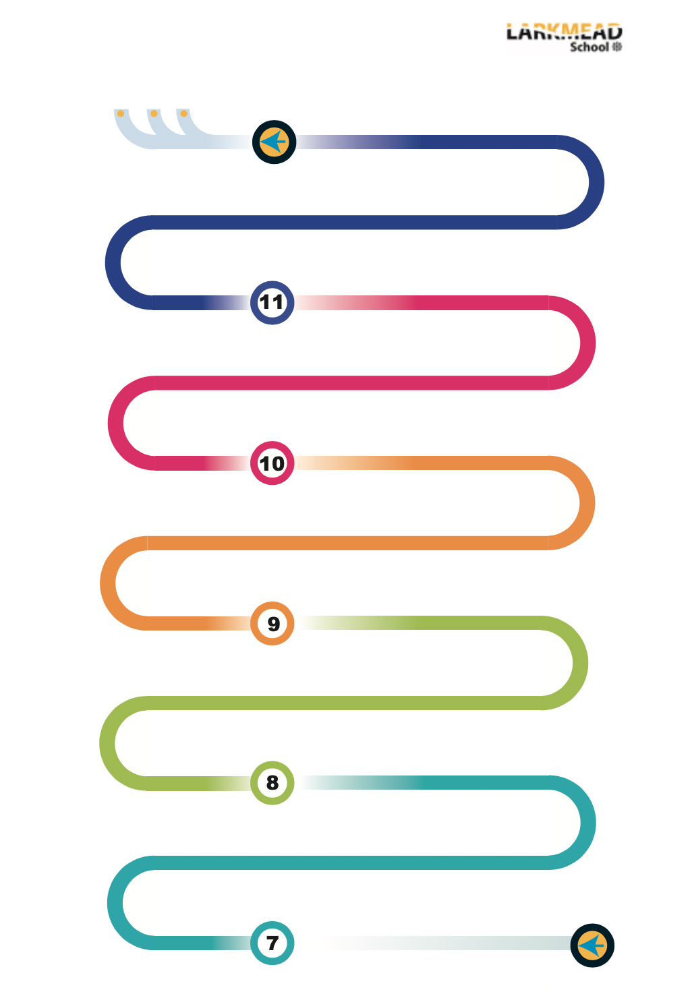

Big picture:
The impact of human behaviour
Education:
Is the reason boys outperform girls because schools are sexist?
Families:
Will marriage become a thing of the past?
Education: key studies and focus on research methods
Recap Year 9
Timing and technique for short-answer questions
Perfecting 12 mark questions
Review of GCSE course
Year 12/13: Taster session – A level themes – Society, Education, Crime & Deviance, Social Stratification
Applying research methods to the 4 topics
25 key studies
Crime and Deviance :
Black Lives Matter
Are the police and courts institutionally racist?
Understanding 3-4 mark questions
WTM
Exam Preparation
Exams
Understanding statistics and social policy
Stratification:
Is growing gap between rich and poor by accident or design?
Research methods:
Can you study children and young people if they cannot give their consent?
KS3:
Explore society, culture and values

Explored Through:
History
Geography
Philosophy & Religion

Sociology is an option in Year 8
Understanding 12 mark questions
Research skills
Introduction to research methods
Family topics – links to introductory material
Sociology
Mocks
Feedback
Problem solving skills
Statistics
Social stratification: Key studies and focus on research methods.
Evaluative skills
Crime and Deviance: links to family and education
Introduction to sociological perspectives. Functionalism, Feminism, Marxism, Interactionism
Core concepts – culture, socialisation, norms and values.
Problem solving skills
Evaluation skills
Comparative skills Enquiry skills empatheticem
Analytical skills
Evaluation skills
Comparative skills Enquiry skills empatheticem
Research skills
Best work project
A-Level Sociology
Apprentices
University
Year 10 Exam
Pulling it together
Practice
Revision skills - analysis
Exam skills
Modelling GCSE responses
Independent GCSE responses
engagement
Analytical skills
Induction day

