
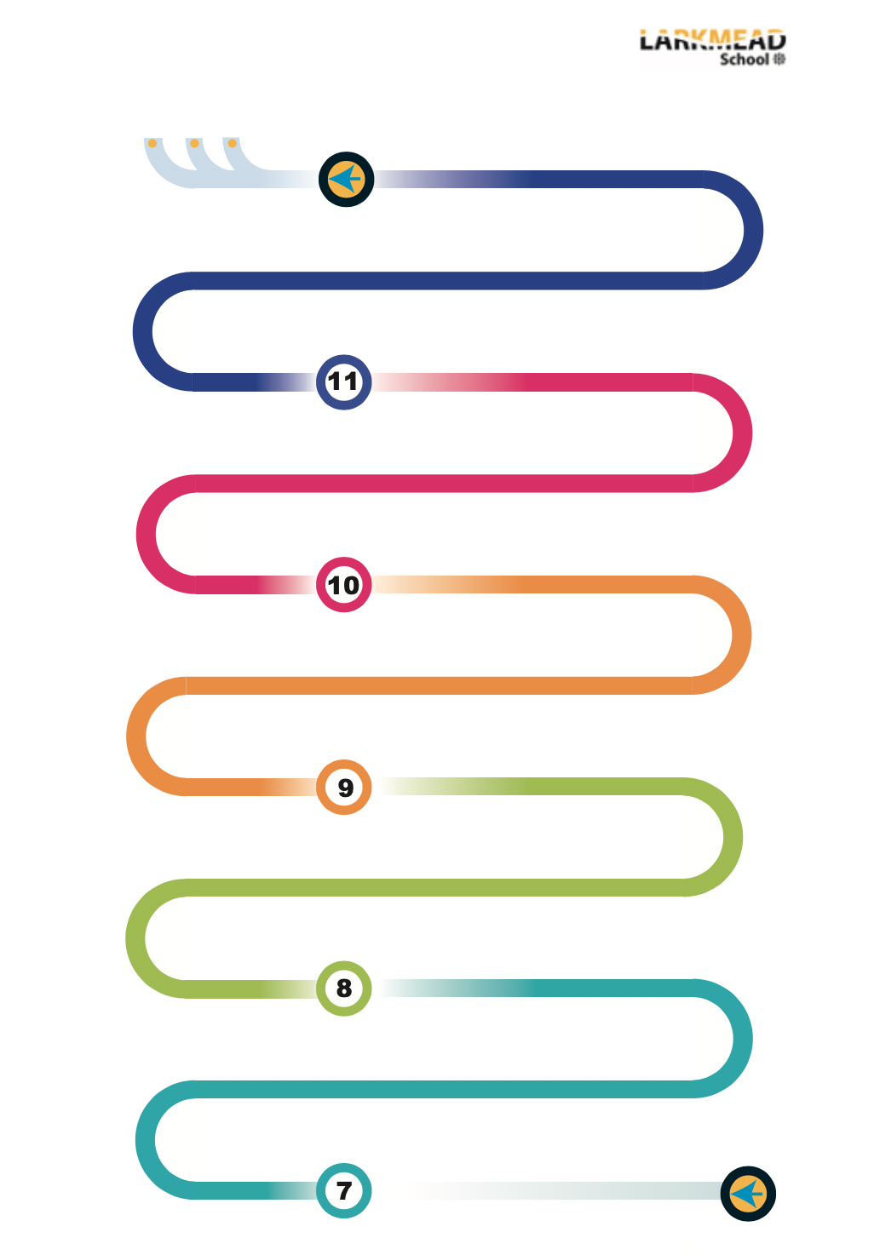

Review of GCSE course
Making sure all knowledge is secure and key skills embedded ready for the GCSE exam
P&R
A-Levels
Apprentices
University
9.1 GCSE Transition Project
Skills and knowledge to start the GCSE course
7.1 What influences us?
The people, places and things which influence us and others
End of year review and test
Developing our key skills and knowledge applying it to GCSE style questions
9.3 Existence of God
Does God exist? Can His existence ever be proven? We explore arguments for and against God’s existence.
9.2 Relationships & Families
Is the nature and make up of families changing? How do the religious and non-religious respond to this?

8.3 Philosophy and Film
Film isn’t just there to entertain us, it can open our minds to a whole new way of thinking.
7.6 Philosopher Queens
Looking at the impact that women have had in the world of philosophy
8.5 Philosophy, Religion and Art
What is beauty and how do people capture what they believe through brushstrokes?
GCSE and next steps
Sitting the GCSE and considering the opportunities of further study (Religious Studies, Philosophy, Politics and other related subjects)
11.2 Christianity: Practices
How do Christians practice their faith?
11.1 Christianity: Beliefs
What are the key beliefs of Christianity and how do they influence a Christian’s life?
10.3 Islam: Practices
How do Muslim’s practice their faith? How do the Five Pillars influence their lives?
End of year review and test
Developing our key skills and knowledge applying it to GCSE style questions
10.2 Islam: Beliefs
What are the key beliefs of Islam and how do they influence a Muslim’s life?
10.1 Dialogue
How do the religious and non-religious respond to different ethical issues?
8.6 The Greatest Ideas of All Time
An exploration of the ideas that changed the way the world thinks

8.4 Religion in society
A lot of society is shaped by religion, but how many people are actually religious?
8.1 Business Ethics
Business isn’t just about making money, it’s also about making the right choices.
7.4 When disaster strikes
Disasters come in many forms, but what is the right way to respond?
9.4 Religion, Peace and Conflict
Should we ever go to war, or should we keep peace at all costs?
Best work project
Introduction to Philosophy, Religion and Ethics
7.5 Religion in the Media
How are religions portrayed in the media and is it fair?
8.2 Religion and Science
Often thought of in conflict, but do they actually complement each other?
7.2 Should we follow rules?
Introduction to political philosophy and the question of who is in charge and why?
7.3 Moral Maze
Questions of morality are rarely straightforward. Sometimes it is a challenge to get our minds around

