
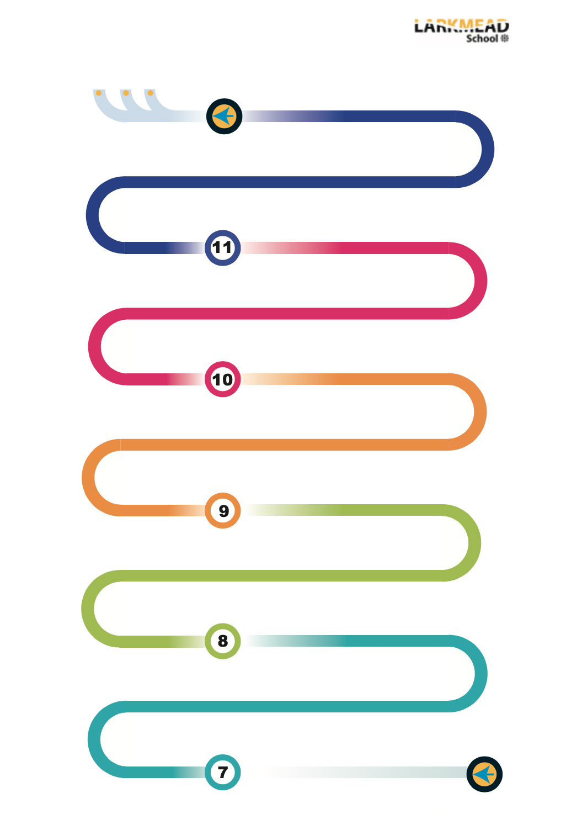

How have Historians researched the Tudors?
Medicine in 18th and 19th century Britain
Norman England, 1066-88
Anglo-Saxon England and the Norman Conquest, 1060-66
William I in power: securing the kingdom, 1066-87
The end of the Cold War, 1970-91
Cold War crises, 1958-70
The origins of the Cold War, 1941-58
Nazi control and dictatorship, 1933-39
Life in Nazi Germany, 1933-39
Hitler’s rise to power, 1919-1923
The Weimar Republic, 1918-29
The British Sector of the Western Front, 1914-1918: injuries, treatments and trenches
Medicine in medieval England, c1250-c1500
The Medical Renaissance in England, c1500-c14700
The Holocaust
Medicine in modern Britain, c1900-present
How tolerant was post-war Britain?
WWII: Key turning points
How did the Industrial Revolution change Britain?
Why did the allied nations win WWI?
Why did war break out in 1914?
What happened between the wars?
How do interpretations of slavery differ?
What was life like in medieval England?
How was life different in medieval Islamic civilisations?
The English Civil War
History
A-Levels
Apprentices
University
At KS4, You will be assessed a minimum of twice a term, using a mixture of quizzes, exam questions and review work
Assessment: What was the experience of black Tudors?
Assessment: Why did William win the Battle of Hastings?
How did the Normans keep control of England?
Assessment: How did the Bocksten Man die?
Assessment: How significant were the Crusades?
What impact did the Crusades have?
Assessment: Cromwell: Hero or Villan?
Making of the Modern World
Assessment: usefulness of sources on slavery
Assessment: What was the most important cause of WWI?
Assessment: Should Britain have been proud by 1900?
Assessment: What caused WWII?
Assessment: How can we remember the Holocaust?
Assessment: What was the most significant turning point of WWII?
Medicine through time, c1250-present
Weimar and Nazi Germany, 1918-1939
Superpower relations and the Cold War, 1941-91
Anglo-Saxon and Norman England, c1060-1088
Exam preparation
1066: conquest and control
Why is history significant?
What are the key concepts in history?
Conquest and control
Best work project
What is history?
How do we use sources in history?

